Functional Specifications
FOR
Volunteer Management System (VMS)
(VMS)

CLIENT
PROJECT | Volunteer Management System (VMS)
TITLE | Functional Specifications
VERSION | 1.0
DATE | 16-Aug-2011
 | ORIGINATOR
 | Name / Signature | Team 8S
 | APPROVAL
 | Name / Signature | Phung Kim Cuong, Dio
Institute of Systems Science |  | Document Reference
25 Heng Mui Keng Terrace  Singapore 119615 |  | VMS/T-1.4.1/1

 | Acceptance
 | Customer Signature |  | Customer Signature
 | Name & Designation |  | Name & Designation
 | Date & Company Stamp |  | Date & Company Stamp

Revision History

Date | Version | Description | Author
16-Aug-2011 | 1.0 | Creation | Team 8S

Table of Contents

Table of Contents ii
1. Use Case Model Survey 7
1.1 Introduction 7
1.2 Survey Description 7
1.3 Actors 7
1.4 Use Case 8
2. UCRR (Analysis) – Security Management 13
2.1 Brief Description 13
2.2 Flow of Events 13
2.3 Standard Flow 13
2.4 Exceptions 15
2.5 Interaction Diagrams 16
2.6 Participating Objects 18
2.7 Class Diagram 19
2.8 Derived Requirements 19
3. UCRR (Analysis) – Register Volunteer Account 21
3.1 Brief Description 21
3.2 Flow of Events 21
3.3 Standard Flow 21
3.4 Exceptions 22
3.5 Interaction Diagrams 23
3.6 Participating Objects 23
3.7 Class Diagram 24
3.8 Derived Requirements 24
4. UCRR (Analysis) – Update Profile 26
4.1 Brief Description 26
4.2 Flow of Events 26
4.3 Standard Flow 26
4.4 Exceptions 27
4.5 Interaction Diagrams 28
4.6 Participating Objects 28
4.7 Class Diagram 29
4.8 Derived Requirements 29
5. UCRR (Analysis) – Raise Interest 31
5.1 Brief Description 31
5.2 Flow of Events 31
5.3 Standard Flow 31
5.4 Exceptions 32
5.5 Interaction Diagrams 32
5.6 Participating Objects 32
5.7 Class Diagram 33
5.8 Derived Requirements 33
6. UCRR (Analysis) – Propose Project 35
6.1 Brief Description 35
6.2 Flow of Events 35
6.3 Standard Flow 35
6.4 Exceptions 36
6.5 Interaction Diagrams 36
6.6 Participating Objects 36
6.7 Class Diagram 37
6.8 Derived Requirements 37
7. UCRR (Analysis) – Post Experience 39
7.1 Brief Description 39
7.2 Flow of Events 39
7.3 Standard Flow 39
7.4 Exceptions 39
7.5 Interaction Diagrams 40
7.6 Participating Objects 40
7.7 Class Diagram 41
7.8 Derived Requirements 41
8. UCRR (Analysis) – Post General Feedback 43
8.1 Brief Description 43
8.2 Flow of Events 43
8.3 Standard Flow 43
8.4 Exceptions 43
8.5 Interaction Diagrams 44
8.6 Participating Objects 44
8.7 Class Diagram 45
8.8 Derived Requirements 45
9. UCRR (Analysis) – Request for Certificate 47
9.1 Brief Description 47
9.2 Flow of Events 47
9.3 Standard Flow 47
9.4 Exceptions 48
9.5 Interaction Diagrams 48
9.6 Participating Objects 48
9.7 Class Diagram 49
9.8 Derived Requirements 49
10. UCRR (Analysis) – Manage Project 51
10.1 Brief Description 51
10.2 Flow of Events 51
10.3 Standard Flow 51
10.4 Exceptions 53
10.5 Interaction Diagrams 55
10.6 Participating Objects 58
10.7 Class Diagram 60
10.8 Derived Requirements 60
11. UCRR (Analysis) – Review Project Proposal 62
11.1 Brief Description 62
11.2 Flow of Events 62
11.3 Standard Flow 62
11.4 Exceptions 63
11.5 Interaction Diagrams 64
11.6 Participating Objects 64
11.7 Class Diagram 65
11.8 Derived Requirements 65
12. UCRR (Analysis) – Assign Role to Project Member 67
12.1 Brief Description 67
12.2 Flow of Events 67
12.3 Standard Flow 67
12.4 Exceptions 68
12.5 Interaction Diagrams 69
12.6 Participating Objects 69
12.7 Class Diagram 70
12.8 Derived Requirements 71
13. UCRR (Analysis) – Manage Itinerary 73
13.1 Brief Description 73
13.2 Flow of Events 73
13.3 Standard Flow 73
13.4 Exceptions 76
13.5 Interaction Diagrams 77
13.6 Participating Objects 79
13.7 Class Diagram 81
13.8 Derived Requirements 81
14. UCRR (Analysis) – Manage Calendar 83
14.1 Brief Description 83
14.2 Flow of Events 83
14.3 Standard Flow 83
14.4 Exceptions 85
14.5 Interaction Diagrams 86
14.6 Participating Objects 89
14.7 Class Diagram 91
14.8 Derived Requirements 91
15. UCRR (Analysis) – Review Feedback 93
15.1 Brief Description 93
15.2 Flow of Events 93
15.3 Standard Flows 93
15.4 Exceptions 93
15.5 Interaction Diagrams 94
15.6 Participating Objects 94
15.7 Class Diagram 95
15.8 Derived Requirements 95
16. UCRR (Analysis) – Review Project Interest 97
16.1 Brief Description 97
16.2 Flow of Events 97
16.3 Standard Flow 97
16.4 Exceptions 98
16.5 Interaction Diagrams 98
16.6 Participating Objects 99
16.7 Class Diagram 100
16.8 Derived Requirements 100
17. UCRR (Analysis) – Print Certificate 102
17.1 Brief Description 102
17.2 Flow of Events 102
17.3 Standard Flow 102
17.4 Exceptions 102
17.5 Interaction Diagrams 103
17.6 Participating Objects 103
17.7 Class Diagram 104
17.8 Derived Requirements 104
18. UCRR (Analysis) – Generate Certificate By Batch 106
18.1 Brief Description 106
18.2 Flow of Events 106
18.3 Standard Flow 106
18.4 Exceptions 106
18.5 Interaction Diagrams 107
18.6 Participating Objects 107
18.7 Class Diagram 108
18.8 Derived Requirements 108
19. UCRR (Analysis) – Generate Separate Certificate 110
19.1 Brief Description 110
19.2 Flow of Events 110
19.3 Standard Flow 110
19.4 Exceptions 110
19.5 Interaction Diagrams 111
19.6 Participation Objects 111
19.7 Class Diagram 112
19.8 Derived Requirements 112
20. UCRR (Analysis) – Generate Report 114
20.1 Brief Description 114
20.2 Flow of Events 114
20.3 Standard Flow 114
20.4 Exceptions 114
20.5 Interaction Diagrams 114
20.6 Participating Objects 115
20.7 Class Diagram 115
20.8 Derived Requirements 116
21. UCRR (Analysis) – Search Project Feedback 118
21.1 Brief Description 118
21.2 Flow of Events 118
21.3 Standard Flow 118
21.4 Exceptions 119
21.5 Interaction Diagrams 119
21.6 Participating Objects 119
21.7 Class Diagram 120
21.8 Derived Requirements 120
22. UCRR (Analysis) – Search Project Member 122
22.1 Brief Description 122
22.2 Flow of Events 122
22.3 Standard Flows 122
22.4 Exceptions 122
22.5 Interaction Diagrams 124
22.6 Participating Objects 124
22.7 Class Diagram 125
22.8 Derived Requirements 125
23. UCRR (Analysis) – Search Project Proposal 127
23.1 Brief Description 127
23.2 Flow of Events 127
23.3 Standard Flow 127
23.4 Exceptions 128
23.5 Interaction Diagrams 128
23.6 Participating Objects 128
23.7 Class Diagram 129
23.8 Derived Requirements 130
ANNEX D Amendment History 131

Use Case Model Survey

Introduction
The purpose this document is to provide a brief description of the project and to describe known actors and their interaction with the system. This document presents a high level view. The main requirements for the system are defined in “User Requirements Specification for Volunteer Management System”, reference VMS/T-1.2/1. The system is to be developed using object-oriented techniques and the Java programming language. For more detailed information, the reader will need to see the individual use case reports.

Survey Description
The scope of this document is to describe the functions that can be performed in the volunteer management system.

Actors

User
This actor represents the general user of the System. The user role can perform login/logout and basic profile update such as Change Password or update details.

Anonymous User
This actor represents public user who have not yet registered as a user of VMS. The Anonymous User can register as a User, or browse the list of projects in the System.

Volunteer
This actor represents a volunteer who is registered and to participate in doing volunteer work at project sites. He can be a project member or project leader for a project site. He will be able to browse for projects and raise interest on projects that he is interested in. He will also be able to post personal experience and feedback regarding a project. He also can request for certification of volunteer work and manage his own profile. Anyone outside the organization can register himself as a volunteer in order to participate in the project site.

Staff
This actor represents organization staffs who work for the volunteer organisation. A staff will be able to perform tasks that a normal user can do. A staff profile will just have different user information compare to volunteer profile.

Administrator
This actor represents a system administrator who manages the user accounts within the system, generate certificates and update system parameters.

Coordinator
This actor represents a project coordinator that participates in reviewing of itinerary and project. Project coordinator also can generate the project report to see the status of certain project.

Project Manager
This actor represents a project manager that is in charge of managing the project sites that has been assigned. He can perform manage the itinerary and calendar for each assigned project site. He also reviews feedback and project interest that has been submitted by volunteers. In addition, PM also performs assignment of volunteers to appropriate projects, submitting project itinerary for reviews or request certificates for the volunteers.

Use Case

Login / Logout
This use case allows the user to login and logout of the system when he wishes to use the system or to exit the system.

Change Password
This use case allows all the users of the system to change their password.

Retrieve Forgotten Password
This use case allows all users of the system to retrieve the password in the event that they have forgotten their password. The password will be email to their registered email.

Register User Account
This use case allows anyone who is interested to become a volunteer to register an account in the system.

Update Profile
This use case allows all the users who have a registered account in the system to update their user profile details. They also can change the password if they want. Refer to use case 4.2 for detail.

Browse Project
This use case allows anyone to browse the list of projects that are within the volunteer organisation. Only certain project information will be visible for public view, certain information will require users to be a registered user to see.

Browse Member of the Project
This use case allows the registered user to browse the member list of projects. Only certain member information will be visible, certain information will require users to be a special role to see.

Propose Project
This use case allows a volunteer or staff to propose a volunteer project to the organisation.

Raise Project Interest
This use case allows a volunteer to raise interest for projects that he is interested in to participate in helping.

Post Project Experience
This use case allows a volunteer to post personal story or interesting experience to share with the public. The experience will go through review and approval before being published for public view.

Post General Feedback
This use case allows a volunteer to post the feedback regarding any matter to the organization.

Request for Certificate
This use case allows a volunteer to request for certificate on the project site that he has participated. It also allows a project manager to request for certificate on behalf of his project team.

Manage Project Details
This use case allows a project manager to manage the details of the project that he is in charge of.

Assign Role to Project Member
This use case allows a project manager to assign volunteers as project members or project leader to the various projects.

Review Feedback
This use case allows a project manager to review and response to feedback that is posted by volunteers.

Review Project Interest
This use case allows a project manager to review a list of requested volunteers who wishes to join a specific project

Send Project Invitation
This use case allows project manager to compile an invitation, and then send it to all volunteers via email, inviting them to join a certain project. The email will contain the link to the page where volunteer can response to the invitation and indicate their preferences. The process to join a project is similar to use case “Raise Project Interest”.

Manage Calendar
This use case allows a project manager to setup a calendar by referencing the approved project itinerary.

Submit Project Itinerary
This use case allows a project manager to submit the prepared itinerary for approval.

Manage Project Itinerary
This use case allows a project manager to search his existing project itinerary, create, update and view a new project itinerary.

Review Project Itinerary
This use case allows a coordinator to search, to review and decide whether to approve or reject a submitted itinerary.

Review Project Proposal
This use case allows a project coordinator to search the list of proposal, to review and to decide whether to approve or reject it. The discussion to approve or reject is done outside the system.

Generate Project Report
This use case allows the project coordinator or project manager to generate reports about the project.

Manage Staff / Volunteer Account
This use case allows the Administrator to register, to view, and to manage the staff account. The Administrator can also manage the volunteer account. Only certain details of these accounts will be modifiable by the administrator.

Generate Certificate
This use case allows the system administrator to generate certificates for multiple volunteers or for individual when there is request of certification from project manager or volunteers.

Configure System Parameter
This use case allows the Administrator to configure certain system-wide parameter that will affect all users.

Overall Use Case Model Survey

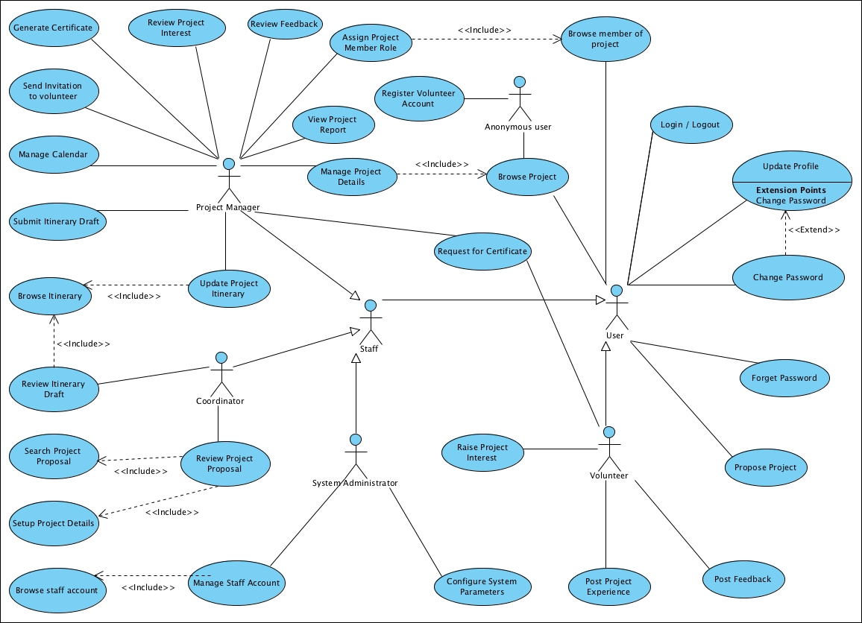
Figure 1 – Overall Use Case Model Survey

Use Case Realisation Report (Analysis) – security MANAGEMENT
FOR
Volunteer Management System (VMS)
(VMS)

UCRR (Analysis) – Security Management

Brief Description
The use case describes the security management of VMS system. Registered users can login/logout of the system. Meanwhile, User is able to make changes to password after login. And registered User can also request for a new password when he/she forgets the old password.

Flow of Events
The standard flow of events for this use case and any exceptions are described in the following subsections. See section 2.5 for an overview of the participating Actors and Domain Objects.

Standard Flow
This use case provides the user interface related functionality that will be provided to the User, as follows:

Log-In
To commence using the system functions, the User is required to login as follows:
To commence using the system functions, the User is required to login as follows:
- When the Anonymous User clicks ‘Login’ link on the NAVMenu, the NAVMenu.login() is triggered and it will trigger MainController.redirectURL() method to redirect the system to SecurityScreen.
- MainController.redirectURL() will use SecurityScreen.show() to display an authentication form to enable user to input registered username and password.
- Anonymous User enters the email address and password on the screen
- When Anonymous User click ‘submit’ button, the SecurityScreen.onSubmit() method is triggered and it will use SecurityScreen.validFormat() method to perform format checking.
- After format checking, SecurityController.validUserPassword() is triggered to do username and password authentication
- SecurityController.validUserPassword() will first use method User.getAllUsers() method to fetch all the Registered User Objects and compare the received username with these objects . If the received UserName cannot be found, SecurityController.validUserPassword() will use SecurityScreen .displayMsg() operation to instruct the SecurityScreen to display ‘The username has not been registered’
- If username already exists in the database, , SecurityController.validUserPassword() will use User.validatePassword() method to compare the received password and the password stored in the object, and return a response to , SecurityController.validUserPassword() informing whether the password is valid or not
- If the password id valid, SecurityController.validUserPassword() will use SecurityScreen.displayMsg() to display ‘Successful login’
- If the password is invalid, SecurityController.validUserPassword() will use SecurityScreen.displayMsg() operation to instruct the SecurityScreen to display ‘Invalid password’.
- Upon a successful login, SecurityController.validUserPassword() will trigger HomeScreen.show() to redirect the system to HomeScreen.
11. The use case terminates

Change Password
If the User logs in successfully, he/she will be able to update his/her password as follows:
- When the User clicks ‘Change password’ on the NAVMenu, NAVMenu.changePassword() is triggered.
- NAVMenu.ChangePassword() will trigger MainController.redirectURL() to redirect current screen to SecurityScreen.
- After SecurityScreen.show() is triggered, the authentication form will be displayed to enable user to enter old password and new password.
- User will enter the old password and new password. When the user click ‘Change Password’ button, SecurityScreen.onSubmit() is triggered and it will perform the format validation of new password.
- If the format is not valid, SecurityScreen.displayMsg() will be triggered to display ‘Invalid format.’
- Upon the successful validation, the SecurityController.changePassword() will be triggered and it will call the User.getUserbyUserName() method to get the User Object.
- The SecurityController.changePassword() will use the User.validatePassword()to compare the received password with the one in the object.
- If the password is invalid, the SecurityController.changePassword() will use SecurityScreen.displayMsg() to display ‘Incorrect old password.’
- If the old password is valid, the SecurityController.changePassword() will use the method User.setPassword() to set the new password.
- After setting the new password, the SecurityController.changePassword() will use the method SecurityScreen.displayMsg() to display ‘Password has been changed successfully.’
- SecurityController. changePassword () will trigger HomeScreen.show() to redirect the system to HomeScreen.
- The use case terminates.

Log-Out
- When the User clicks ‘Log Out’ link on the NAVMenu, NAVMenu.logOut() is triggered and it will trigger MainController.logOut() method
- MainController.logOut() will use SecurityController.logout() to clear the user information
- SecurityController.logout() will clear the current session information of the user.
- Upon the successful logout, SecurityController.logout() will use HomeScreen.show() to redirect the system to the home screen.
- The use case terminates.

Request for New Password
- When the User clicks ‘Request for New Password’ link on the NAVMenu, NAVMenu .requestPassword() is triggered and it will use MainController.redirectURL() to redirect current screen to SecurityScreen.
- MainController.redirectURL() will use SecurityScreen.show() to display the SecurityScreen.
- The input form will be displayed to enable user to enter the username.
- User will enter the username.
- When user click ‘Submit’ button, the SecurityScreen.onSubmit() is triggered and it will use the SecurityController.requestPassword() to get Password.
- The SecurityController.requestPassword() will verify if the user has already registered or not. If not, SecurityController.requestPassword() will use the method SecurityScreen.displayMsg() to display ‘User Name does not exist in the system’.
- If yes, the MailServer.sendEmail() is triggered and new password will be sent to the user by email.
- The SecurityController.requestPassword() verifies if the user has already registered or not. If not, SecurityController will use the method SecurityScreen.displayMsg() to display ‘User Name does not exist in the system.’
- SecurityController. requestPassword () will use HomeScreen.show() to redirect the system to the home screen
- The use case terminates.

Exceptions
The following exceptions have been identified:
- Invalid Password. If User still failed to enter the correct password after ten attempts. The user account will be locked.
- Invalid New Password. If the new password is not conforming to the security format, system will prompt the format tips to assist users.
- Invalid email address. If the email address is not registered, system will display an error message.

Interaction Diagrams

Collaboration Diagram for Login
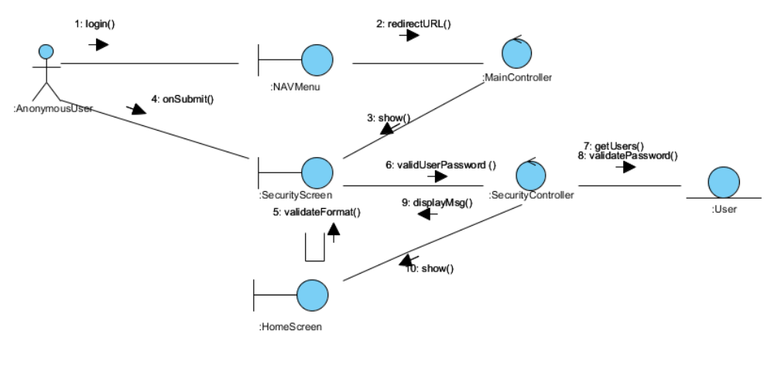
Figure 2 – Collaboration Diagram for Login

Collaboration Diagram for Change Password
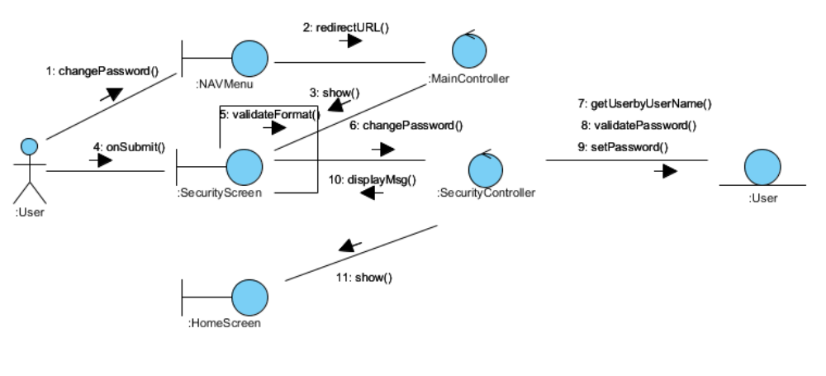
Figure 3 – Collaboration Diagram for Change Password

Collaboration Diagram for Logout
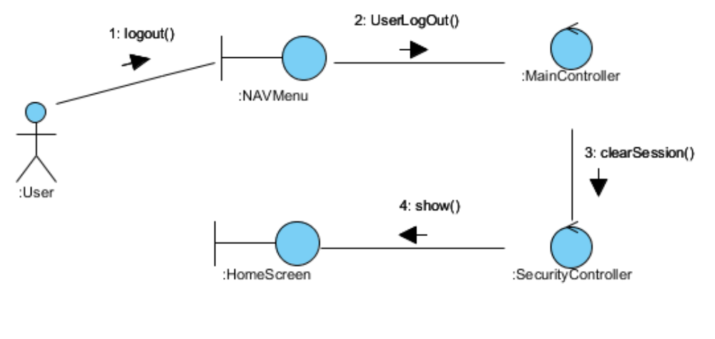
Figure 4 – Collaboration Diagram for Logout

Collaboration Diagram for Request for New Password
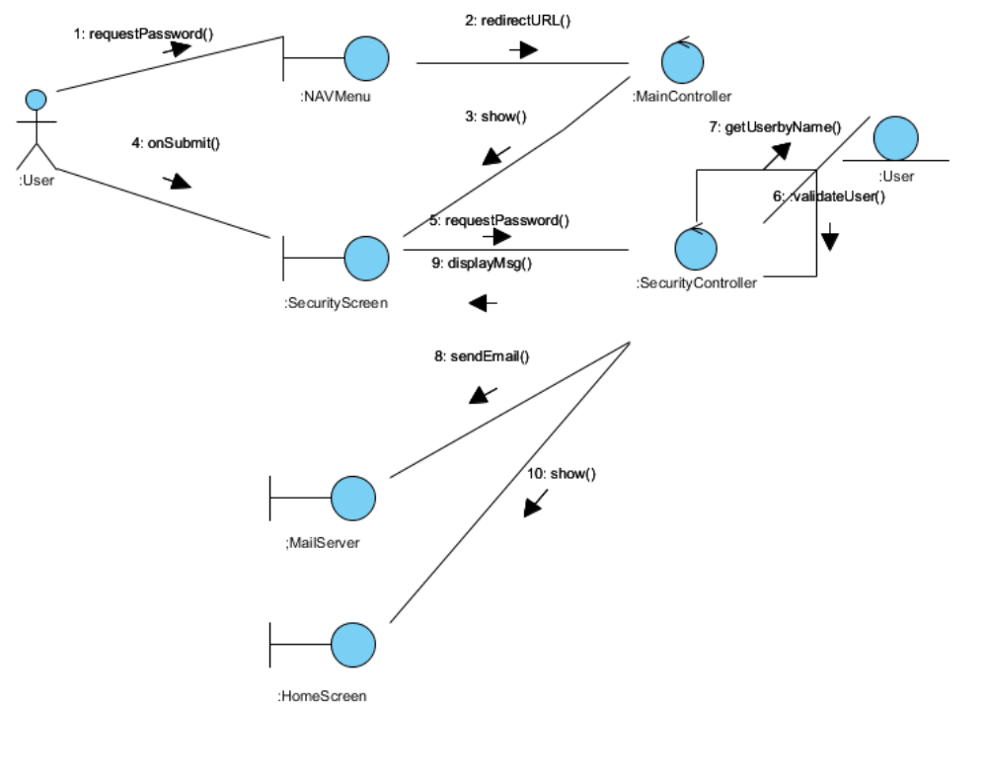
Figure 5 – Collaboration Diagram for Request for New Password

Participating Objects

Anonymous User (Actor)
This actor represents public user who have not yet registered as a user of VMS. The Anonymous User can register as a User, or browse the list of projects in the System.

User (Actor)

This actor represents the general user of the System. The user role can perform login/logout and basic profile update such as Change Password or update details

User(Entity)
This entity object stores the details concerning a user of the volunteer organisation. The primary attribute that it holds is the userID.

SecurityScreen
This boundary object is used to display security form and exchange security information with controllers.

NAVMenu
This boundary object is used to display system navigation map for user account related operations.

HomeScreen
This boundary object is used for redirecting and displaying of home screen details and menu. All the user actors use this object.

MailServer
This boundary object is used to interact with email service interface.

MainController
This control object co-ordinates the menu selection and dispatches of requests of the volunteer management system. It delegates the user requests to the specific use case control objects for carrying out the use cases.

SecurityController
This control object co-ordinates the authentication, retrieval and update of security information.

Class Diagram
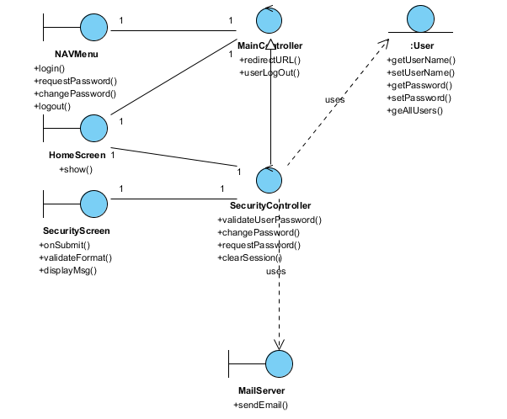
Figure 6 – Class Diagram

Derived Requirements
The User office PC (client system), keyboard and mouse will be used to process the project details and view all the system responses.

Use Case Realisation Report (Analysis) – Register volunteer account
FOR
Volunteer Management System (VMS)
(VMS)

UCRR (Analysis) – Register Volunteer Account

Brief Description
The use case describes the new volunteer account registration of VMS system.

Flow of Events
The standard flow of events for this use case and any exceptions are described in the following subsections. See section 3.6 for an overview of the participating Actors and Domain Objects.

Standard Flow
This use case provides the user interface related functionality that will be provided to the User, as follows:
To commence using the system functions, the Anonymous User can sign for a new account as follows:
- Anonymous User clicks ‘Register Volunteer Account’ URL on HomeScreen. The HomeScreen.registerVolunteer() will be triggered.
- HomeScreen.registerVolunteer() will use MainController.redirectURL() to rediect current screen to SecurityScreen.
- When SecurityScreen.show() is invoked, a new user input form will be displayed to enable Anonymous User enter following information:
  - Email address
  - Password
  - Full Name
  - Date of Birth
  - Gender
  - Nationality
  - Interests
  - Language Proficiency
  - Profession
  - Contact
  - Address
- When Anonymous User click ‘Submit’ button, the SecurityScreen.onSubmit() will use the SecurityScreen.validateFormat() to check the input info format.
- If the user info isn’t correct, SecurityScreen.displayMsg() is triggered to display the error message on the screen.
- If the use info is correct, SecurityController.createNewUser() method will be triggered.
- SecurityController.createNewUser() will use SecurityController.validateUserInfo() to validate use input.
- The SecurityController. validateUserInfo () use the getAllUsers() of User entity to get a list of registered users.
- If the user mail has already existed, SecurityScreen.displayMsg() is triggered to display the error message on the screen.
- If the user mail has not registered, the User.create() method of User object will be triggered to create a new object and save to database.
- The MailServer.sendEmail() method is used to send an email to user.
- SecurityScreen.displayMsg() method is triggered to display the success message on the screen.
- SecurityController.createNewUser() will use HomeScreen.show() to display HomeScreen upon the successful new account registration.
- The use case terminates.
.

Exceptions
The following exceptions have been identified:
- Invalid Password. If the new password doesn’t conform to the security format, system will prompt the format tips to assist users
- Email address already registered. If the email address is already registered, system will prompt error message

Interaction Diagrams

Collaboration Diagram for Register Volunteer Account
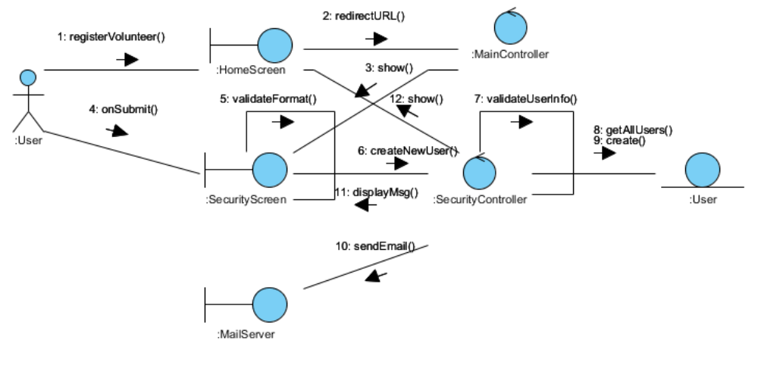
Figure 7 – Collaboration Diagram for Register Volunteer Account

Participating Objects

Anonymous User(Actor)

This actor represents public user who have not yet registered as a user of VMS. The Anonymous User can register as a User, or browse the list of projects in the System

User
This entity object stores the details concerning a user of the volunteer organisation. The primary attribute that it holds is the userID.

SecurityScreen
This boundary object is used to display security form and exchange security information with controllers.

HomeScreen
This boundary object is used for redirecting and displaying of home screen details and menu. All the user actors use this object.

MailServer
This boundary object is used to interact with email service interface.

MainController
This control object co-ordinates the menu selection and dispatches of requests of the volunteer management system. It delegates the user requests to the specific use case control objects for carrying out the use cases.

SecurityController
This control object co-ordinates the authentication, retrieval and update of security information.

Class Diagram
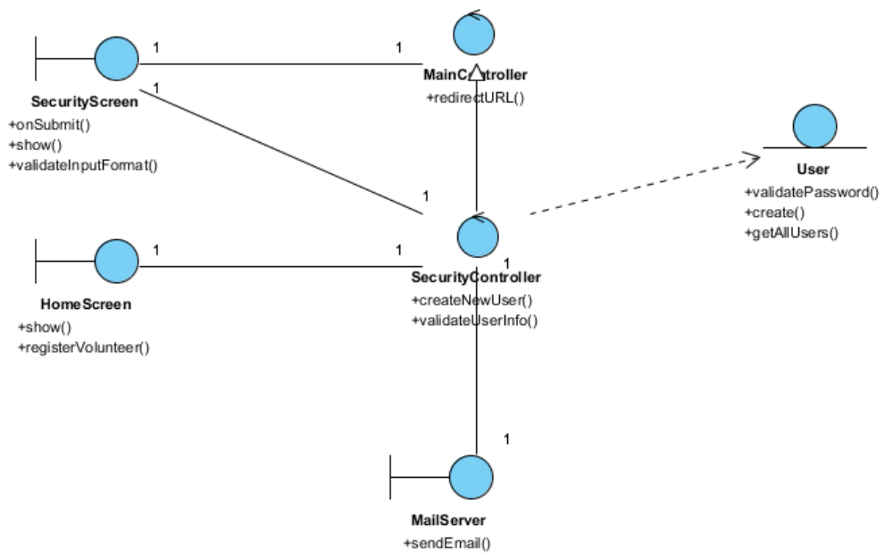
Figure 8 – Class Diagram

Derived Requirements
The User office PC (client system), keyboard and mouse will be used to process the project details and view all the system responses.

Use Case Realisation Report (Analysis) – Update Profile
FOR
Volunteer Management System (VMS)
(VMS)

UCRR (Analysis) – Update Profile

Brief Description
The use case enables registered User to update his/her profile.

Flow of Events
The standard flow of events for this use case and any exceptions are described in the following subsections. See section 4.6 for an overview of the participating Actors and Domain Objects.

Standard Flow
Precondition: User has logged in the system.
This use case provides the user interface related functionality that will be provided to the User, as follows:
- When the User clicks ‘Update Profile’ link on the HomeScreen, the method HomeScreen.updateProfile() will be triggered and it will use MainController.redirectURL() method to redirect to UserProfileScreen.
- The MainController.redirectURL() will use the UserProfileScreen.show() method to display a input form enabling the User to edit personal info
- UserProfileScreen.show() will fetch the user details by calling the method UserController.getUserDetails()
- The UserProfileScreen.show() method will use User.getUserFullName()/Nationality/DOB/Gender/LaunguageProficiency/Profession/Contact/Address to populate User detailed information on the screen.
- The User can edit following info:
- Full Name
- Nationality
- Date of Birth
- Gender
- Language Proficiency
- Profession
- Contact
- Address
- When user click ‘Update’ button, The UserProfileScreen .onSubmit() method will be triggered and it will use UserProfileScreen.validateFormat() method to perform basic format checking.
- After checking is done, the UserProfileScreen will use the UserController .updateUserProfile() method to update the user info by calling User.update() .
- UserController.updateUserProfile() will use the UserProfileScreen.displayMsg() method to display a confirmation message to User.
- The use case terminates.

Exceptions
The following exceptions have been identified:
- Invalid Information Format. If any of inputs information is incompatible, system will display a validation summary for user to make amendments.

Interaction Diagrams

Collaboration Diagram for Update profile
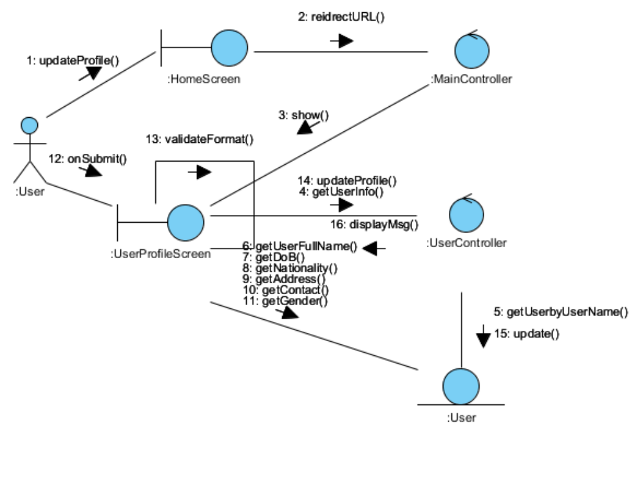
Figure 9 – Collaboration Diagram for Update Profile

Participating Objects

User (Actor)

This actor represents the general user of the System. The user role can perform login/logout and basic profile update such as Change Password or update details

User(Entity)
This entity object stores the details concerning a user of the volunteer organisation. The primary attribute that it holds is the userID.

UserProfileScreen
This boundary object is used to display user profile info and allow user to edit the profile information.

HomeScreen
This boundary object is used for redirecting and displaying of home screen details and menu. All the user actors use this object.

MainController
This control object co-ordinates the menu selection and dispatches of requests of the volunteer management system. It delegates the user requests to the specific use case control objects for carrying out the use cases.

UserController
This control object co-ordinates the user information update, creation and retrieval.

Class Diagram
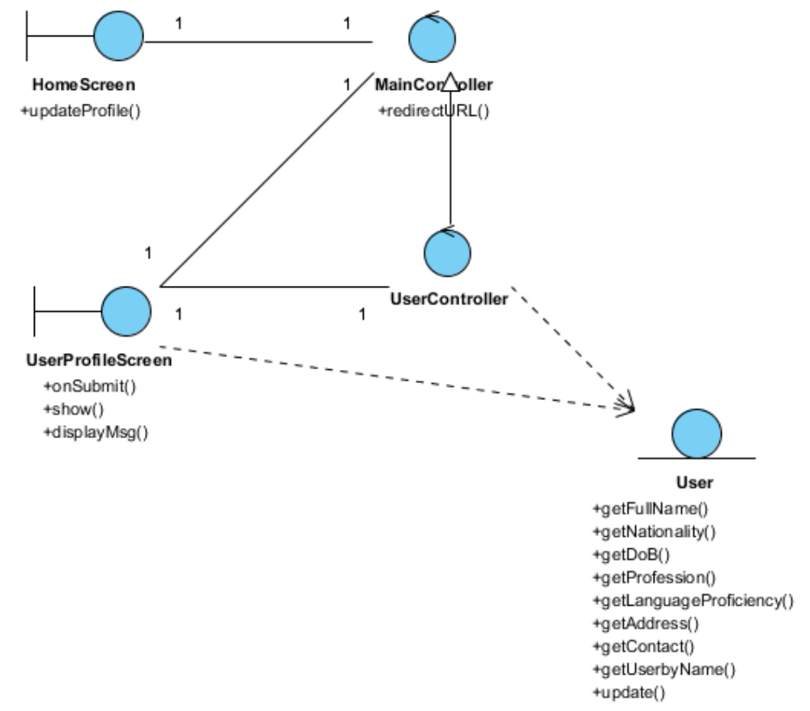
Figure 10 – Class Diagram

Derived Requirements
The User office PC (client system), keyboard and mouse will be used to process the project details and view all the system responses.

Use Case Realisation Report (Analysis) – Raise Interest
FOR
Volunteer Management System (VMS)
(VMS)

UCRR (Analysis) – Raise Interest

Brief Description
The use case enables registered user raise interest to a project that they are interested in .

Flow of Events
The standard flow of events for this use case and any exceptions are described in the following subsections. See section 5.5 for an overview of the participating Actors and Domain Objects.

Standard Flow
Precondition: Volunteer has logged in the system and View Project Use Case has been performed.
This use case provides the user interface related functionality that will be provided to the User, as follows:
- When the Volunteer clicks ‘raise Interest’ button on the ViewProjectScreen, the ViewProjectScreen.raiseInterest() method is triggered.
- ViewProjectScreen.raiseInterest() uses the method ProjectController .addProjectInterest() to create a new project membership request.
- ProjectController will first fetch the projectID from the Project Object by using method Project.getProjectId().
- Then ProjectController will use the ProjectInterest.create() method of ProjectInterest object to create an new instance with the volunteer userName and projectId.
- Finally, the ProjectController will use ViewProjectScreen.displayMsg() to notify the volunteer that a new request has been sent for Project Manager review.
- The use case terminates.

Exceptions

Interaction Diagrams

Collaboration Diagram for Raise Interest
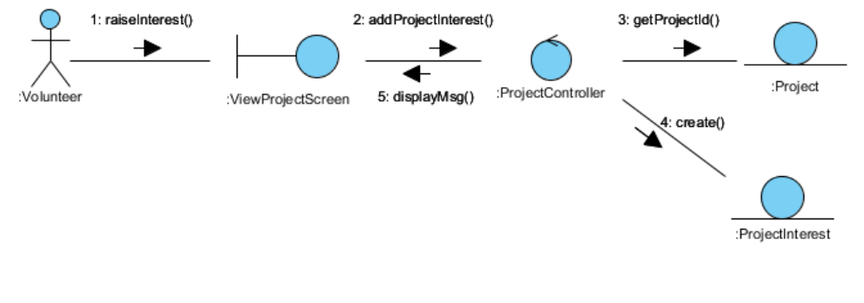
Figure 11 – Collaboration Diagram for Raise Interest

Participating Objects

Volunteer(Actor)
This actor represents a person a volunteer who wishes to participate in doing volunteer work at project sites. He can be a project member or project leader for a project site. A volunteer can register himself as a volunteer in order to participate in the project site.

ViewProjectScreen
This boundary object is used to display details of project info that Volunteer selected.

ProjectController
This control object co-ordinates the creation, update, viewing and searching project record in the volunteer management system. It receives requests from the boundary objects allocated for the specific purposes, along with all the necessary details required for the execution of these requests.

ProjectInterest
This entity object stores the request concerning poject membership application. The primary attribute that it holds is the userID and projectID.

Project
This entity object stores the details concerning a project of the volunteer organisation. The primary attribute that it holds is the projectID.

Class Diagram
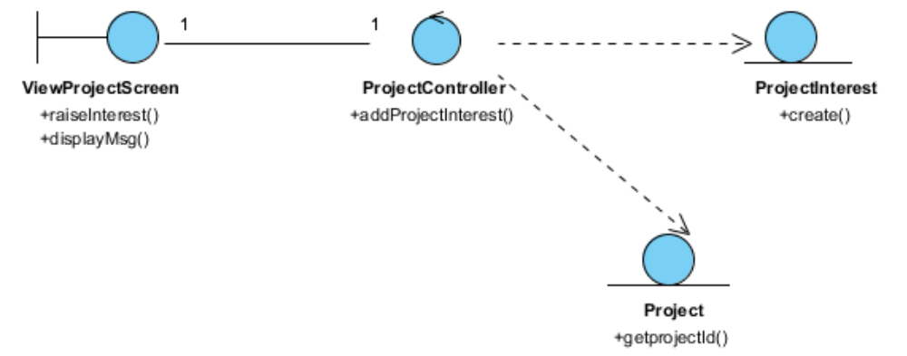
Figure 12 – Class Diagram

Derived Requirements
The Volunteer office PC (client system), keyboard and mouse will be used to process the project details and view all the system responses.

Use Case Realisation Report (Analysis) – Propose Project
FOR
Volunteer Management System (VMS)
(VMS)

UCRR (Analysis) – Propose Project

Brief Description
The use case enables registered user to propose new project.

Flow of Events
The standard flow of events for this use case and any exceptions are described in the following subsections. See section 6.5 for an overview of the participating Actors and Domain Objects.

Standard Flow
Precondition: Volunteer has logged in the system.
This use case provides the user interface related functionality that will be provided to the Volunteer, as follows:
- When Volunteer clicks ‘Propose New Project’ button on the ProjectListingScreen, ProjectListingScreen.proposeNewProject() is triggered and it will trigger ProjectController.proposeNewProject() method.
- ProjectController.proposeNewProject() will use ProposePojectScreen.show() to display the ProposePojectScreen to Volunteer
- The project proposal form will be displayed on the ProposePojectScreen, including the following fields:
- Project Name
- Project Description
- Country
- Location
- Estimated Duration
- Proposer
- The Volunteer can edit each field and he/she can also upload supporting documents on the screen by calling ProposePojectScreen.uploadDocument()
- When the user click ‘Submit’, the ProposePojectScreen.onSubmit() will be triggered and it will use ProjectController.proposeProject() to create and submit a new project proposal
- The ProjectController.proposeProject() will use the ProjectController .validateProjectProposal() to perform business validation of user input information.
- After validation, the ProjectProposal.create() method is triggered to create a new ProjectProposal object .
- If Volunteer uploads documents, the Document.create() is triggered to create one or more Document objects
- ProposeProjectScreen.displayMsg() is used to display an confirmation message to Volunteer.
- ProjectController.proposeProject() will call ProjectListingScreen.show() to redirect the system to the ProjectListingScreen.
- The use case terminates.

Exceptions
The following exceptions have been identified:
- Invalid Information Format. If any of input information is incompatible, system will display a validation summary for user to make amendment.

Interaction Diagrams

Collaboration Diagram for Propose Project
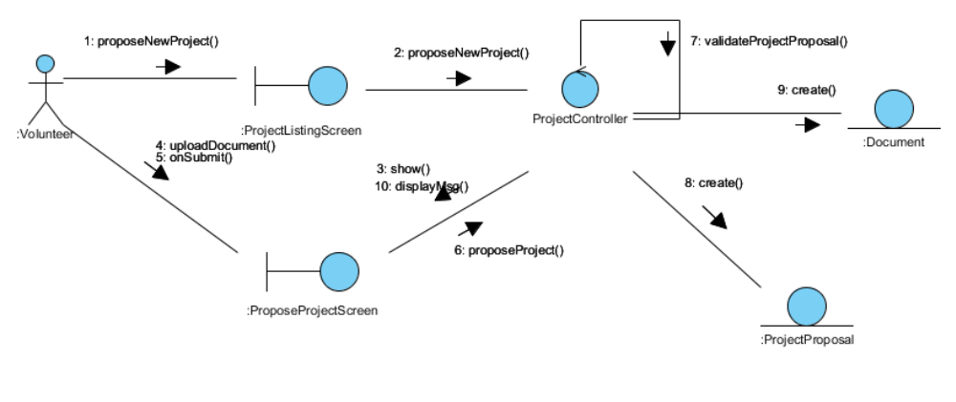
Figure 13 – Collaboration Diagram for Propose Project

Participating Objects

Volunteer(Actor)
This actor represents a person a volunteer who wishes to participate in doing volunteer work at project sites. He can be a project member or project leader for a project site. A volunteer can register himself as a volunteer in order to participate in the project site.

ProjectProposal
This entity object stores the details concerning a project proposal that volunteer created. The primary attribute that it holds is the proposalID.

Document
This entity object stores the details concerning a document that volunteer uploaded. The primary attribute that it holds is the docID.

ProjectListingScreen
This boundary object is used for collection of project listing details. User actor uses this object.

ProjectProposalScreen
This boundary object is used for collection of project proposal. The Volunteer actor uses this object.

ProjectController
This control object co-ordinates the creation, update, viewing and searching project record in the volunteer management system. It receives requests from the boundary objects allocated for the specific purposes, along with all the necessary details required for the execution of these requests.

Class Diagram
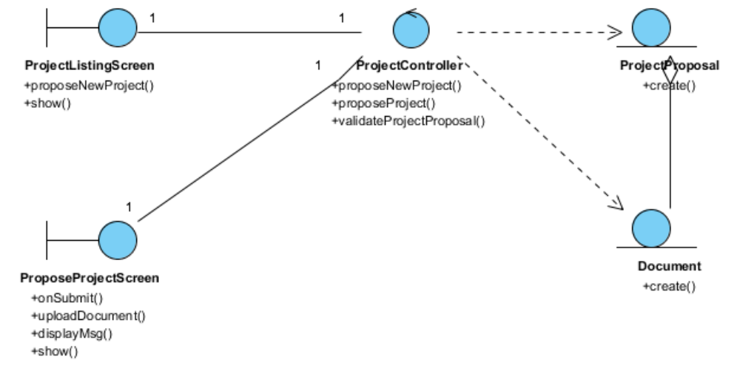
Figure 14 – Class Diagram

Derived Requirements
The Volunteer office PC (client system), keyboard and mouse will be used to process the project details and view all the system responses.

Use Case Realisation Report (Analysis) – Post Experience
For
Volunteer Management System (VMS)
(VMS)

UCRR (Analysis) – Post Experience

Brief Description
The use case enables registered user to propose new project.

Flow of Events
The standard flow of events for this use case and any exceptions are described in the following subsections. See section 7.6 for an overview of the participating Actors and Domain Objects.

Standard Flow
Precondition: Volunteer has logged in the system and use case View Project has been performed.This use case provides the user interface related functionality that will be provided to the User, as follows:
- When the Volunteer clicks ‘Post Experience’ button on the ViewProjectScreen, the ViewProjectScreen.postExperience() is triggered.
- ViewProjectScreen.postExperience() will use ProjectController.redirectURL() to redirect current screen to UserStoryScreen.
- After UserStoryScreen.show() method is triggered, a new form will be displayed enabling Volunteer to enter text.
- Volunteer can also upload documents by triggering UserStoryScreen.uploadDocument()
- After user click ‘Submit’ button, UserStoryScreen.onSubmit() will be triggered and it will trigger ProjectController.createUserStory() method
- ProjectController.createUserStory() will create a new UserStory object by using UserStory.create() with user input info.
- ProjectController.createUserStory() will create one or more Document objects by using Document.create() to save user uploaded docs or images.
- ProjectController.createUserStory() will use UserStoryScreen.displayMsg() to display a confirmation msg to the volunteer.
- The use case terminates.

Exceptions
No exceptions have been identified.

Interaction Diagrams

Collaboration Diagram for Post Experience
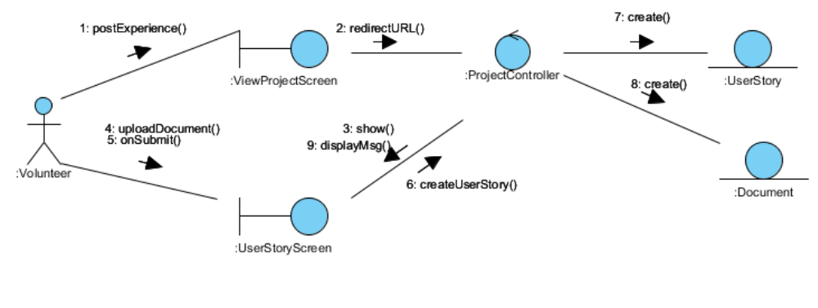
Figure 15 – Collaboration Diagram for Post Experience

Participating Objects

Volunteer(Actor)
This actor represents a person a volunteer who wishes to participate in doing volunteer work at project sites. He can be a project member or project leader for a project site. A volunteer can register himself as a volunteer in order to participate in the project site.

UserStory
This entity object stores the details concerning a user experience that volunteer created. The primary attribute that it holds is the userStoryID.

Document
This entity object stores the details concerning a document that volunteer uploaded. The primary attribute that it holds is the docID.

ViewProjectScreen
This boundary object is used for collection of project details. User actor uses this object.

UserStoryScreen
This boundary object is used for collection of user story. The Volunteer actor uses this object.

ProjectController
This control object co-ordinates the creation, update, viewing and searching project record in the volunteer management system. It receives requests from the boundary objects allocated for the specific purposes, along with all the necessary details required for the execution of these requests.

Class Diagram
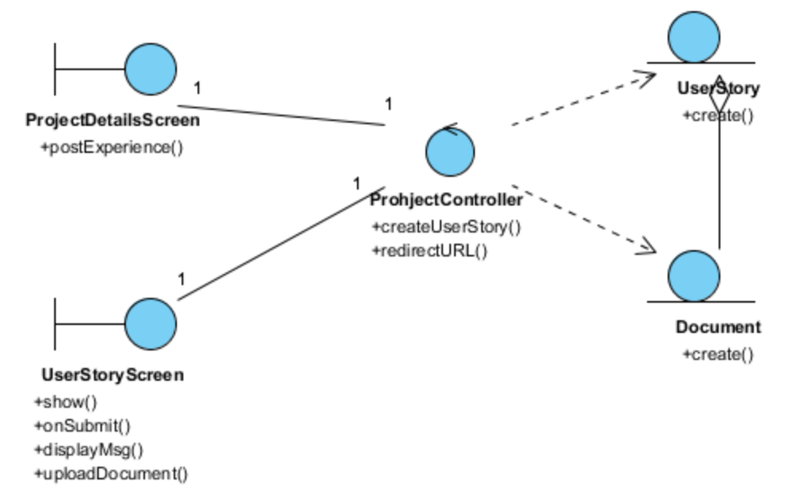
Figure 16 – Class Diagram

Derived Requirements
The Volunteer office PC (client system), keyboard and mouse will be used to process the project details and view all the system responses.

Use Case Realisation Report (Analysis) – Post General Feedback
FOR
Volunteer Management System (VMS)
(VMS)

UCRR (Analysis) – Post General Feedback

Brief Description
The use case enables registered user to post general feedback regarding a project.

Flow of Events
The standard flow of events for this use case and any exceptions are described in the following subsections. See section for an overview of the participating Actors and Domain Objects.

Standard Flow
Precondition: Volunteer has logged in the system and use case View Project has been executed
This use case provides the user interface related functionality that will be provided to the Volunteer, as follows
- When Volunteer clicks ‘Post Feedback’ button on the ViewProjectScreen, the ViewProjectScreen.postFeedback() method is triggered.
- ProjectDeatilsScreen uses the method ProjectController.redirectURL() to display the UserFeedbackScreen to Volunteer.
- ProjectController.redirectURL() will use UserFeedbackScreen.show() method to show a new input form to Volunteer.
- Volunteer can also enter the text in the form.
- Volunteer can also upload supporting document or attach images using UserFeedbackScreen.uploadDocumnet().
- When Volunteer click ‘Submit’ button, UserFeedbackScreen.onSubmit() will be triggered and it will trigger the ProjectController. createFeedback() method
- ProjectController will create a new UserFeedback object with user input info by using UserFeedback.create().
- ProjectController will create one or more Document objects to save user uploaded docs or images.
- ProjectController will use UserFeedbackScreen.displayMsg() to display a confirmation message to the volunteer.
- The use case terminates.
.

Exceptions
No exceptions have been identified.

Interaction Diagrams

Collaboration Diagram for Post General Feedback
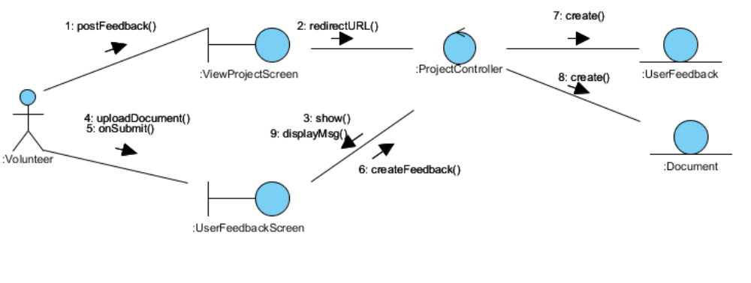
Figure 17 – Collaboration Diagram for Post General Feedback

Participating Objects

Volunteer(Actor)

This actor represents a person a volunteer who wishes to participate in doing volunteer work at project sites. He can be a project member or project leader for a project site. A volunteer can register himself as a volunteer in order to participate in the project site

UserFeedback
This entity object stores the details concerning a user feedback that volunteer created. The primary attribute that it holds is the userStoryID.

Document
This entity object stores the details concerning a document that volunteer uploaded. The primary attribute that it holds is the docID.

ViewProjectScreen
This boundary object is used for collection of project details. User actor uses this object.

UserFeedbackScreen
This boundary object is used for collection of feedback. The Volunteer actor uses this object.

ProjectController
This control object co-ordinates the creation, update, viewing and searching project record in the volunteer management system. It receives requests from the boundary objects allocated for the specific purposes, along with all the necessary details required for the execution of these requests.

Class Diagram
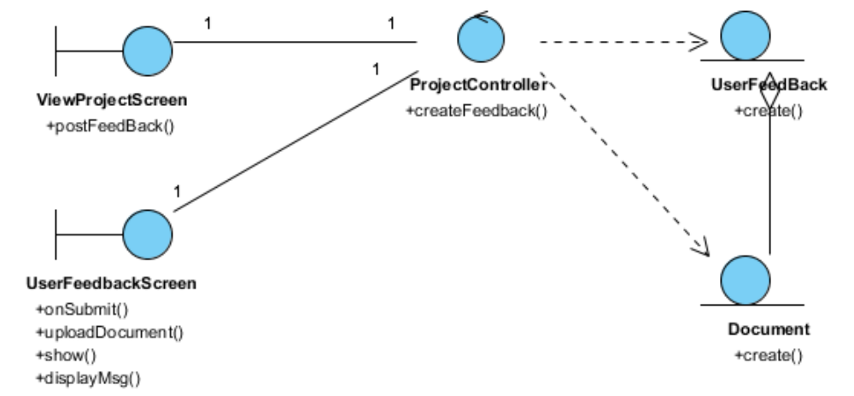
Figure 18 – Class Diagram

Derived Requirements
The User office PC (client system), keyboard and mouse will be used to process the project details and view all the system responses.

Use Case Realisation Report (Analysis) – Request for Certificate
FOR
Volunteer Management System (VMS)
(VMS)

UCRR (Analysis) – Request for Certificate

Brief Description
The use case enables the Volunteer to request for certificate of project that he/she has participated in.

Flow of Events
The standard flow of events for this use case and any exceptions are described in the following subsections. See section 9.6 for an overview of the participating Actors and Domain Objects.

Standard Flow
Precondition: Volunteer has logged in and View Project use case has been performed.
This use case provides the user interface related functionality that will be provided to the Volunteer as follows:
- When the volunteer clicks ‘Request For Certificate’ button, the method ViewProjectScreen.requestForCertificate() is triggered and it will in turn trigger ProjectController .requestCertificate().
- The ProjectController.requestCertificate() will use the method Project.getProjectStatus() to get current status of this particular project.
- ProjectController.requestCertificate() will use the Volunteer.getParticipantsbyProjectId() method to get a list of Volunteers that have engaged in the project.
- ProjectController.requestCertificate() will use ProjectController.validateCertificateApplicant() to validate if the certificate applicant is qualified to request for certificate of this project.
- If the project status is not active, the ProjectController.requestCertificate() will use ViewProjectScreen.displayMsg() method to display error message ‘The Project status is incorrect’.
- If the username of Volunteer is not found among the project participants, the ProjectController.requestCertificate() will use ViewProjectScreen.displayMsg() to display error message ‘Only Project Participants can request for the certificate’.
- After validation, the ProjectController.requestCertificate() will use the CertificateRequest .create() method to create a new CertificateRequest Object
- ProjectController will use the ViewProjectScreen.displayMsg() to display confirmation message ‘The certificate request has been sent for Project Manager review’.
- The use case terminates.
.

Exceptions
The following exceptions have been identified:
  - Invalid Project Status. If selected project is not in ‘active’ status, system will prompt error message.
  - Invalid Applicant. If the volunteer is not a valid applicant to request certificate, system will display an error message for volunteer.

Interaction Diagrams

Collaboration Diagram for Request for Certificate
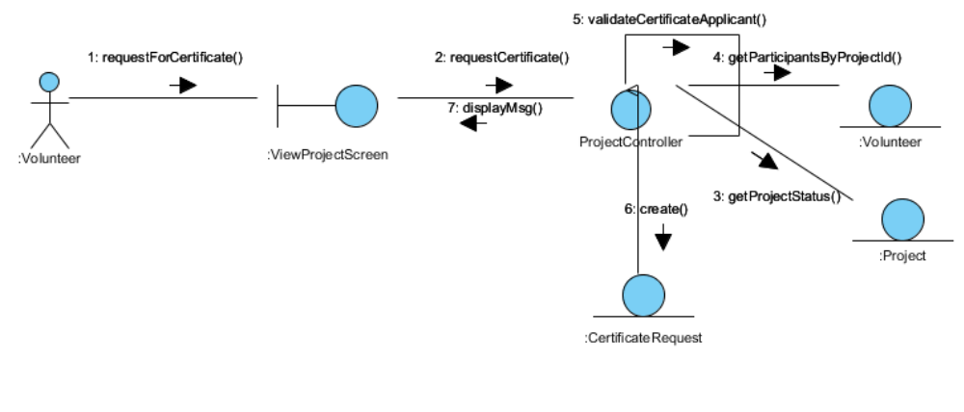
Figure 19 – Collaboration Diagram for Request for Certificate

Participating Objects

Volunteer(Actor)
This actor represents a person a volunteer who wishes to participate in doing volunteer work at project sites. He can be a project member or project leader for a project site. A volunteer can register himself as a volunteer in order to participate in the project site.

Volunteer(Entity)
This entity object stores the details concerning a volunteer of the volunteer organisation. The primary attribute that it holds is the userID

CertificateRequest
This entity object stores the details concerning a certificate request that volunteer created. The primary attribute that it holds is the certificateRequestID.

Project
This entity object stores the details concerning a project. The primary attribute that it holds is the projectID.

ViewProjectScreen
This boundary object is used for collection of project listing details. User actor uses this object.

ProjectController
This control object co-ordinates the creation, update, viewing and searching project record in the volunteer management system. It receives requests from the boundary objects allocated for the specific purposes, along with all the necessary details required for the execution of these requests.

Class Diagram
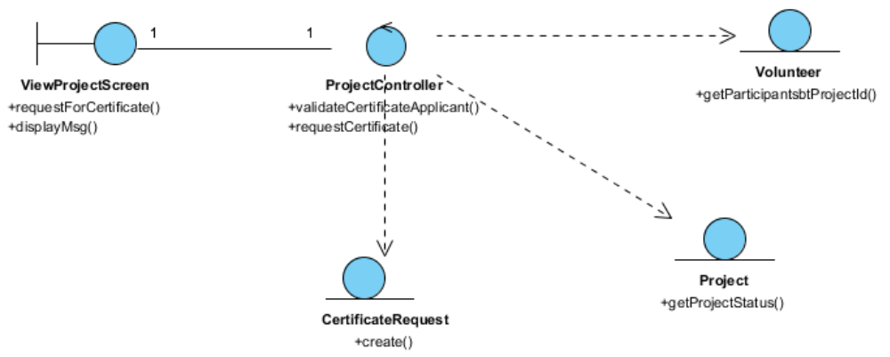
Figure 20 – Class Diagram

Derived Requirements
The User office PC (client system), keyboard and mouse will be used to process the project details and view all the system responses.

Use Case Realisation Report (Analysis) – Manage Project
FOR
Volunteer Management System (VMS)
(VMS)

UCRR (Analysis) – Manage Project

Brief Description
The use case enables the Project Manager to perform management of project sites that he is in-charge of.

Flow of Events
The standard flow of events for this use case and any exceptions are described in the following subsections. See section 10.5 for an overview of the participating Actors and Domain Objects.

Standard Flow
Precondition: Project Manager has logged in the system.
This use case provides the user interface related functionality that will be provided to the Project Manager for interaction with regards to project management, as follows:

List Project
- The User is not required to be logged in to the system to perform use case.
- The use case starts when the User selects the project option from the HomeScreen. The HomeScreen.getProjectListMenu() operation is triggered.
- The getProjectList() operation triggers the MainController.getProjectList() which delegates to the ProjectController.getProjectList() operation.
- Using the userID, the ProjectController.getProjectList() operation triggers Project.getProject() operation to retrieve the project records. The ProjectController.getProjectList() operation triggers the Staff.getStaff() operation to retrieve the user record.
- The ProjectController triggers the ProjectListingScreen.show() operation to display the list of projects by triggering the Project.getAttribute() operation and Staff.getAttribute() operation.
- The use case terminates.

Search Project
- Project Manager has logged in the system.
- The use case starts when the User selects the search project option from the ProjectListingScreen. The ProjectListingScreen.getViewSearch() operation is triggered.
- The ProjectController.getViewSearch() triggers the SearchProjectScreen.show() operation to display the SearchProjectScreen.
- The User enters a number of criteria for the project into the SearchProjectScreen and selects the Search button. The SearchProjectScreen.search() operation is triggered which in term triggers the ProjectController.getProjectBySearchCriteria() using the search criteria of project name, country, location, start date, project status and project manager to perform the search.
- The ProjectController triggers the Project.getProject() operation and Staff.getStaff() operation to retrieve the information of the project.
- The ProjectController triggers the ProjectListingScreen.show() operation to display the list of projects by triggering the Project.getAttribute() operation and Staff.getAttribute() operation.
- The use case terminates.

View Project
- List Project Use Case has been performed.
- The use case starts when the Project Manager selects a record to view from the ProjectListingScreen. The ProjectListingScreen.getViewProject() operation is triggered which in terms trigger the ProjectController.getViewProject() operation.
- The ProjectController.getViewProject() operation triggers Staff.getStaff() operation to retrieve the user details and the Project.getProject() operation is triggered to retrieve the project details using userID to retirieve projects that only the logon user has access to.
- The ProjectController triggers the ViewProjectScreen.show() operation to display the ViewProjectScreen by triggering the Staff.getAttribute() operation to retrieve the staff detail and the Project.getAttribute() operation to display the details.

Create Project
- The use case starts when the Project Manager selects the create project option from the ProjectListingScreen. The ProjectListingScreen.getViewCreate() operation is triggered.
- Using the userID, the ProjectController.getViewCreate() operation triggers Staff.getStaff() operation to retrieve the user record to default the Project Manager field.
- The ProjectController triggers the Staff.getStaff() to retrieve the Staff object, which in terms triggers the CreateProjectScreen.show() operation to display the CreateProjectScreen by triggering the Staff.getAttribute() operation to retrieve the staff detail for the Project Manager.
- The Project Manager enters the project details of the new project into the text fields of CreateProjectScreen.
- When the Project Manager selects the Create button in the form, the CreateProjectScreen.validate() operation performs form validation based on the input fields.
- Upon successful validation, CreateProjectScreen.createProject() operation triggers the ProjectController.createProject() operation and provides the Project object to create a project. The createProject() operation assigns a new project ID by using the operation Project.getNextProjectID() operation.
- The ProjectController.createProject() operation sets the date of created date of the project which the date is retrieved via the Date.getDate().
- The ProjectController triggers Project.createProject() operation to create the new Project object details including name, description, country, location, startDate and staff detail. The system displays an informational message for successfully updated message in the ProjectListingScreen by triggering the ProjectListingScreen.showMessage() operation.
- The use case terminates.

Update Project
- List Project Use Case has been performed.
- The use case starts when the Project Manager selects the update project option from the ProjectListingScreen. The ProjectListingScreen.getViewUpdate() operation is triggered.
- The ProjectController.getViewUpdate() operation triggers Staff.getStaff() operation to retrieve the user details and the Project.getProject() operation is triggered to retrieve the project details.
- The ProjectController triggers the UpdateProjectScreen.show() operation to display the UpdateProjectScreen by triggering the Staff.getAttribute() operation to retrieve the staff detail and the Project.getAttribute() operation to display the details.
- The Project Manager updates the project details of the project into the text fields of UpdateProjectScreen.
- When the Project Manager selects the Update button in the form, the UpdateProjectScreen.validate() operation performs form validation based on the input fields.
- Upon successful validation, UpdateProjectScreen.updateProject() operation triggers the ProjectController.updateProject() operation and provides the Project object to update the project.
- The ProjectController.updateProject() triggers Project.updateProject() operation to update the new Project object details including name, description, country, location, startDate, endDate, and status. The system displays an informational message for successfully updated message in the ProjectListingScreen by triggering the ProjectListingScreen.showMessage() operation.
- The use case terminates.

Exceptions
The following exceptions were identified:
- Validation fails. If the CreateProjectScreen.validate() operation fails, the project creation fails. An error message is displayed in the CreateProjectScreen by triggering the operation CreateProjectScreen.showMessage().
- Validation fails. If the UpdateProjectScreen.validate() operation fails, the project creation fails. An error message is displayed in the UpdateProjectScreen by triggering the operation UpdateProjectScreen.showMessage().

Interaction Diagrams

Collaboration Diagram for List Project
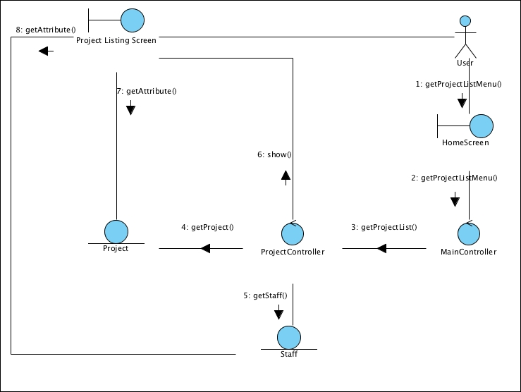
Figure 21 – Collaboration Diagram for List Project

Collaboration Diagram for Search Project
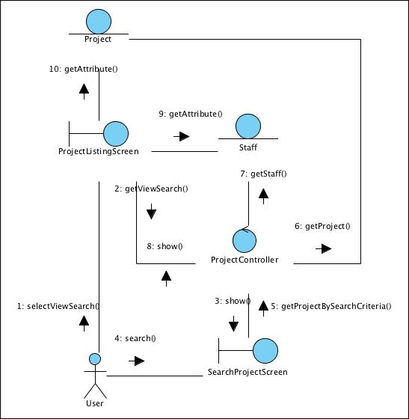
Figure 22 – Collaboration Diagram for Search Project

Collaboration Diagram for View Project
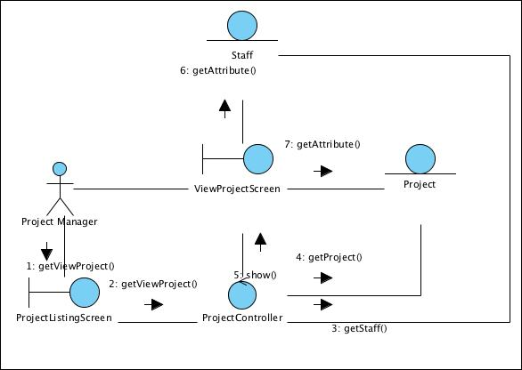
Figure 23 – Collaboration Diagram for View Project

Collaboration Diagram for Create Project
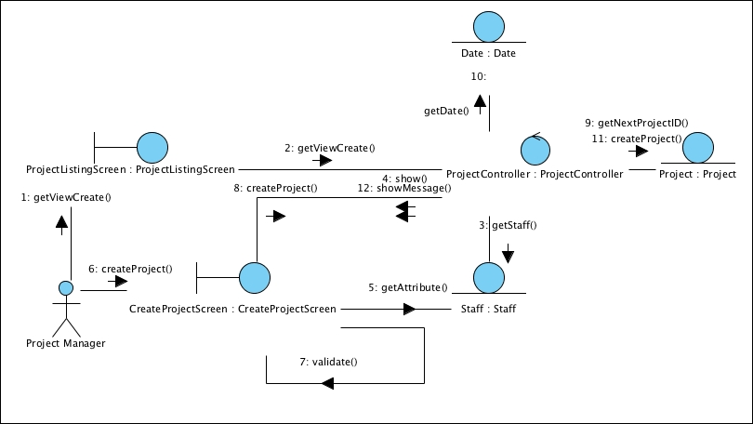
Figure 24 – Collaboration Diagram for Create Project

Collaboration Diagram for Update Project
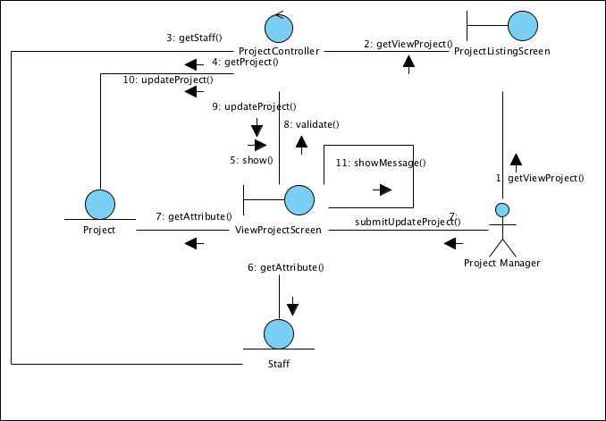
Figure 25 – Collaboration Diagram for Update Project

Participating Objects

Staff
This entity object stores the details concerning a staff of the volunteer organisation. The primary attribute that it holds is the userID.

Project Manager
This is a Staff object type with a project manager role as an attribute.

Date
This entity object stores the current date.

Project
This entity object stores the details concerning a project of the volunteer organisation. The primary attribute that it holds is the projectID.

ProjectListingScreen
This boundary object is used for collection of project listing details. User actor uses this object.

CreateProjectScreen
This boundary object holds information of a new project record is to be created. The Project Manager actor uses this object.

UpdateProjectScreen
This boundary object holds information of a project record is to be updated. The Project Manager actor uses this object.

ViewProjectScreen
This boundary object holds information of a project record is to be viewed. The User actor uses this object.

HomeScreen
This boundary object is used for redirecting and displaying of home screen details and menu. All the user actors use this object.

MainController
This control object co-ordinates the menu selection and dispatches of requests of the volunteer management system. It delegates the user requests to the specific use case control objects for carrying out the use cases.

ProjectController
This control object co-ordinates the creation, update, viewing and searching project record in the volunteer management system. It receives requests from the boundary objects allocated for the specific purposes, along with all the necessary details required for the execution of these requests.

Class Diagram
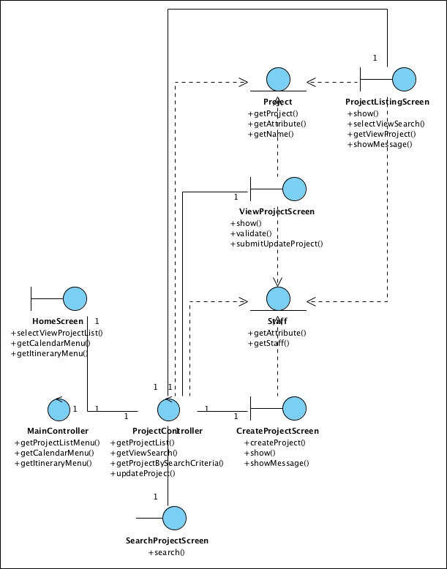
Figure 26 – Class Diagram

Derived Requirements
The Staff office PC (client system), keyboard and mouse will be used to process the project details and view all the system responses.

Use Case Realisation Report (Analysis) – Review PROJECT PROPOSAL
FOR
Volunteer Management System (VMS)
(VMS)

UCRR (Analysis) – Review Project Proposal

Brief Description
The use case enables a Project Coordinator to review the list of project proposal and decide whether to approve or reject the proposal.

Flow of Events
The standard flow of events for this use case and any exceptions are described in the following subsections. See section 11.6 for an overview of the participating Actors and Domain Objects.

Standard Flow
Precondition: User has logged in the system and the user role is project coordinator
The workflow is as below:

Review Project Proposal
- The use case starts when the Coordinator selects the Review Project Proposal menu option from the HomeScreen. The HomeScreen.getProjectProposalScreen() operation is triggered.
- The HomeScreen.getProjectProposalScreen() operation triggers the MainController. getProjectProposalScreen() which delegates to the loadProposalList() operation of the ProposalController.
- The ProposalController will then use the StaffController.getStaffDetails() operation to get an instance of the current logged in staff.
- Then it triggers the getStaff() operation of Staff entity to return an instance of current staff.
- Then the ProposalController will trigger ProjectProposal.getProjectProposal() using the instance of Staff object as parameter to return a list of all project proposal for this current user.
- Then the ProposalController will call the ProjectProposalListingScreen.show() to display the list of project proposal.
- The actor then select a record of proposal and trigger the getProposalDetails operation of the ProjectProposalListingScreen, which in turns delegate to ProposalController.getProposalDetail() operation.
- The ProjectProposalListingScreen.getProposalDetail() operation will call the ProposalController.getProposalDetail() to filter the project proposal list.
- After that, the ProposalController will call the ProposalDetailScreen.show() to display the project proposal record.
- Then the actor can perform the update (reject or approve) the proposal. This action will trigger ProposalDetailScreen.updateProposalDetail()
- Then the ProposalDetailScreen will call the ProposalController.updateProposalDetail() method, which delegate to the ProjectProposal.update() operation
- When the ProjectProposal.update() complete, the ProposalController will display a message via ProposalDetailScreen.showMessage() to inform the actor.
- The use case terminate when the actor click Close button on the ProposalDetailScreen, which trigger ProposalDetailScreen.close() method.

Exceptions
The following exceptions were identified:
- Update fails. If the ProjectProposal.update() operation fails, the project proposal is not updated. An error message will be displayed in the ProposalDetailScreen by the operation ProposalDetailScreen.showMessage().

Interaction Diagrams

Collaboration Diagram for Review Project Proposal
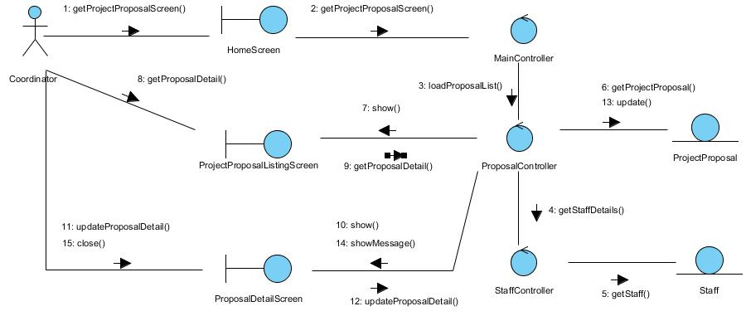
Figure 27 – Collaboration Diagram for Review Project Proposal

Participating Objects

Coordinator
This entity object represents the user with a role of Project Coordinator.

HomeScreen
This boundary object represents the home page of VMS.

ProjectProposalListingScreen
This boundary object is used for collection of project proposal listing. User actor uses this object to select and view a project proposal.

ProposalDetailScreen
This boundary object is used for displaying project proposal details. The Coordinator actor interacts with this object.

MainController
This control object co-ordinates the menu selection and dispatches of requests of the volunteer management system. It delegates the user requests to the specific use case control objects for carrying out the use cases.

ProposalController
This control object co-ordinates the update, viewing and searching project proposal record in the system. It receives requests from the boundary objects allocated for the specific purposes, along with all the necessary details required for the execution of these requests.

ProjectProposal
This entity object represents a record of project proposal in the system. It stores all details regarding project proposal.

Staff
This entity object represents a record of staff in the system. It stores all details regarding staff information.

Class Diagram
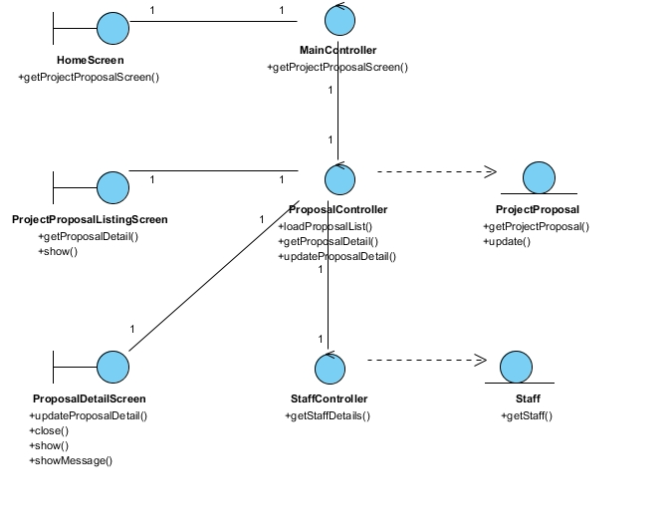
Figure 28 – Class Diagram

Derived Requirements
The User office PC (client system), keyboard and mouse will be used to process the project details and view all the system responses.

Use Case Realisation Report (Analysis) – Assign role to project member
FOR
Volunteer Management System (VMS)
(VMS)

UCRR (Analysis) – Assign Role to Project Member

Brief Description
The use case enables a Project Manager to review the list of project members and to assign the roles to them. The role can be Team Lead or member.

Flow of Events
The standard flow of events for this use case and any exceptions are described in the following subsections. See section 3.1 for an overview of the participating Actors and Domain Objects.

Standard Flow
Precondition: User has logged in the system and the user role is project manager.
The workflow is as below:

Assign Role to Project Member
- The use case starts when the Project Manager selects the menu option from the HomeScreen. The HomeScreen.assignProjectMember() operation is triggered.
- The HomeScreen.assignProjectMember() operation triggers the MainController getProjectMemberScreen() which delegates to the MembershipController’s getMembershipList() operation.
- Using the current logged in userID, the MembershipController will call the StaffController.getStaffDetails().
- Then the Staff.getStaff() operation will be triggered to return an instance of the current staff.
- With the instance of the staff, the ProjectController.getProjectList() will be triggered.
- Then the ProjectController will call Project.getProject() method to return the collect of the projects under this project manager.
- For each of the project, then the MembershipController will call the Membership.getMembership() to return the list of members for that project.
- With the list of project and its members, the MembershipController will call the ProjectMemberScreen.show() method to display the list.
- After that, the Project Manager will key in the role assignment and click Submit, this action will trigger the ProjectMemberScreen.enterMemberAssignment() method.
- The above method will be delegated to MembershipController. enterMemberAssignment() method, which in turn will call the update() method for each Membership entity.
- The MembershipController then display a message to user via sendMessage() method.
- The use case terminates when the Project Manager click Close button on the ProjectMemberScreen, which trigger its close() operation.

Exceptions
No exceptions were identified.

Interaction Diagrams

Collaboration Diagram for Assign Role to Project Member
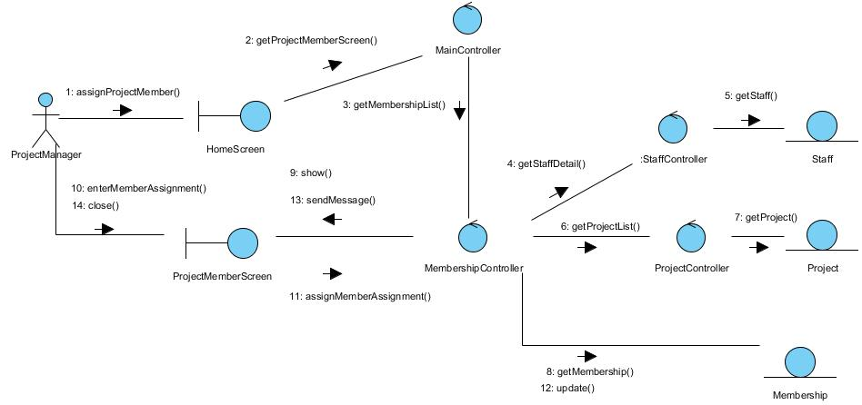
Figure 29 – Collaboration Diagram for Assign Role to Project Member

Participating Objects

Staff
This entity object stores the details concerning a staff of the volunteer organisation. The primary attribute that it holds is the userID.

Project Manager
This is a Staff object type with a project manager role as an attribute.

Project
This entity object stores the details concerning a project of the volunteer organisation. The primary attribute that it holds is the projectID.

Membership
This entity object stores the details of an assignment for each project member.

ProjectMemberScreen
This boundary object is used for collection of project member listing and for member role assignment. Project Manager interact with this object.

HomeScreen
This boundary object is used for redirecting and displaying of home screen details and menu. All the user actors use this object.

MainController
This control object co-ordinates the menu selection and dispatches of requests of the volunteer management system. It delegates the user requests to the specific use case control objects for carrying out the use cases.

MembershipController
This control object co-ordinates the creation, update, viewing and searching project membership in the system. It receives requests from the boundary objects allocated for the specific purposes, along with all the necessary details required for the execution of these requests.

StaffController
This control object co-ordinates the creation, update, viewing and searching of staff in the system. It receives requests from the boundary objects allocated for the specific purposes, along with all the necessary details required for the execution of these requests.

ProjectController
This control object co-ordinates the creation, update, viewing and searching of project in the system. It receives requests from the boundary objects allocated for the specific purposes, along with all the necessary details required for the execution of these requests.

Class Diagram
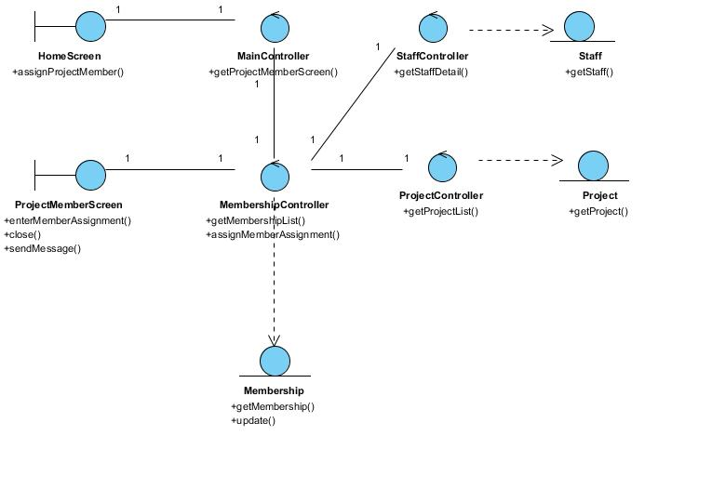
Figure 30 - Class Diagram

Derived Requirements
The Staff office PC (client system), keyboard and mouse will be used to process the project details and view all the system responses.

Use Case Realisation Report (Analysis) – manage ITINERARY
FOR
Volunteer Management System (VMS)
(VMS)

UCRR (Analysis) – Manage Itinerary

Brief Description
The use case enables a User to view an itinerary of events based on month.

Flow of Events
The standard flow of events for this use case and any exceptions are described in the following subsections. See section 13.6 for an overview of the participating Actors and Domain Objects.

Standard Flow
Precondition: User has logged in the system.
This use case provides the user interface related functionality that will be provided to the Project Manager for interaction with regards to itinerary management, as follows:

List Itinerary
- The use case starts when the User selects the calendar option from the HomeScreen. The HomeScreen.getIntineraryMenu() operation is triggered.
- The getCalendarMenu() operation triggers the MainController.getIntineraryMenu() which delegates to the ItineraryController.getTaskList() operation.
- Using the userID and date, the ItineraryController.getItineraryList() operation triggers Task.getTaskList() operation to retrieve the task records using the userID. The ItineraryController.getItineraryList() operation triggers also triggers the Project.getProject() operation to retrieve the project records based on the projectID that is related to the itineraries.
- The ItineraryController triggers the ItineraryListingScreen.show() operation to display the list of projects by triggering the Task.getTaskList() operation and the Project.getName() operation.
- The use case terminates.

View Itinerary
- The use case starts when the User selects a record to view from the ItineraryListingScreen. The ItineraryListingScreen.getItinerary() operation is triggered.
- Using the taskID, the ItineraryController.getItinerary() operation triggers Task.getTask() operation to retrieve the task details based on the taskID and the Project.getProject() operation is triggered to retrieve the project name for this itinerary.
- The ItineraryController triggers the ViewItineraryScreen.show() operation to display the ViewItineraryScreen by triggering the Task.getAttribute() operation to retrieve the event details and Project.getName() to retrieve the project name.
- The use case terminates.

Create Itinerary
- The use case starts when the Project Manager selects the create event option from the ItineraryListingScreen. The ItineraryListingScreen.getViewCreate() operation is triggered.
- The ItineraryController triggers the CreateItineraryScreen.show() operation to display the CreateItineraryScreen.
- The User enters the task details of the new itinerary into the text fields of CreateItineraryScreen.
- When the User selects the Create button in the form, the CreateItineraryScreen.validate() operation performs form validation based on the input fields.
- Upon successful validation, CreateItineraryScreen.createItinerary() operation triggers the ItineraryController.createItinerary() operation and provides the Task object by triggering the Task.getTask() and Project.getProject() operation to retrieve the project object to get the project ID to create a task. The createTask() operation assigns a new task ID by using the operation Task.getNextTaskID() operation.
- The ItineraryController.createItinerary() operation sets the date of created date of the event which the date is retrieved via the Date.getDate().
- The ItineraryController triggers Task.createTask() operation to create the new Task object details including order number, name, description, duration and status. The system displays an informational message for successfully updated message in the ItineraryListingScreen by triggering the ItineraryListingScreen.showMessage() operation.
- The use case terminates.

Update Itinerary
- The use case starts when the User selects a record to update from the ItineraryListingScreen. The ItineraryListingScreen.getViewUpdate() operation is triggered.
- The ItineraryController.getViewUpdate() operation triggers Task.getTask() operation to retrieve the task details and the Project.getProject() operation is triggered to retrieve the project details related to the task.
- The ItineraryController triggers the ViewItineraryScreen.show() operation to display the UpdateItineraryScreen by triggering the Task.getAttribute() operation and Project.getAttribute() to display the details.
- The User selects the Update button to update the updates the project details of the project into the text fields of UpdateItineraryScreen.
- When the User selects the Update button in the form, the UpdateItineraryScreen.validate() operation performs form validation based on the input fields.
- Upon successful validation, UpdateItineraryScreen.updateItinerary() operation triggers the ItineraryController.updateItinerary() operation and provides the Task object to update the task of the itinerary.
- The ItineraryController triggers Task.updateTask() operation to update the new Task object details ncluding order number, name, description, duration and status. The system displays an informational message for successfully updated message in the ItineraryListingScreen by triggering the ItineraryListingScreen.showMessage() operation
- The use case terminates.

Delete Itinerary
- The use case starts when the Project Manager selects the update project option from the ItineraryListingScreen. The update option is performed by the Update Itinerary use case.
- The Project Manager selects the checkbox for the record(s) that is to be deleted and select Delete button to delete the task. The Update The flow is the same as the Update Itinerary use case with the status updated as Submitted.
- The UpdateItineraryScreen.deleteItinerary() operation triggers the ItineraryController.deleteItinerary() operation and provides the Task object to delete the task(s) of the itinerary.
- The system displays an informational message for successfully deletion in the UpdateItineraryScreen by triggering the UpdateItineraryScreen.showMessage() operation
- The use case terminates.

Submit Itinerary
- The use case starts when the Project Manager selects the update project option from the ItineraryListingScreen. The update option is performed by the Update Itinerary use case.
- The Project Manager selects the Submit button to submit the itinerary to the Project Coordinator for approval. The flow is the same as the Update Itinerary use case with the status updated as Submitted.
- The use case terminates.

Review Itinerary
- The use case starts when the Project Coordinator selects the update project option from the ItineraryListingScreen. The update option is performed by the Update Itinerary use case. However, the Project Coordinator can only view the itinerary and to approve or reject the itinerary.
- The Project Manager selects the Approve or Reject button to submit the itinerary to the Project Coordinator for approval. The flow is the same as the Update Itinerary use case with the status updated as Approved or Rejected (depending on the button selected).
- The use case terminates.

Exceptions
The following exceptions were identified:
- Validation fails. If the CreateItineraryScreen.validate() operation fails, the project creation fails. An error message is displayed in the CreateItineraryScreen by triggering the operation CreateItineraryScreen.showMessage().
- Validation fails. If the UpdateItineraryScreen.validate() operation fails, the project creation fails. An error message is displayed in the UpdateItineraryScreen by triggering the operation UpdateItineraryScreen.showMessage().

Interaction Diagrams

Collaboration Diagram for List Itinerary
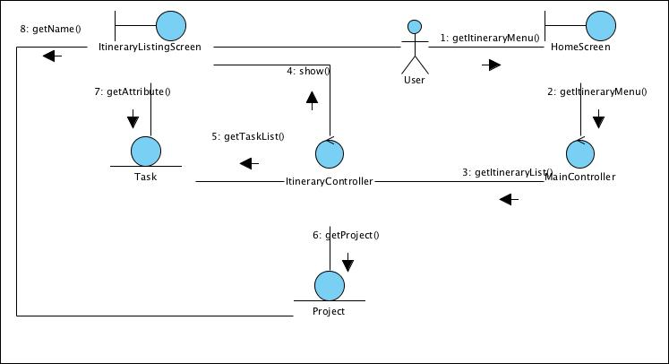
Figure 31 – Collaboration Diagram for List Itinerary

Collaboration Diagram for View Itinerary
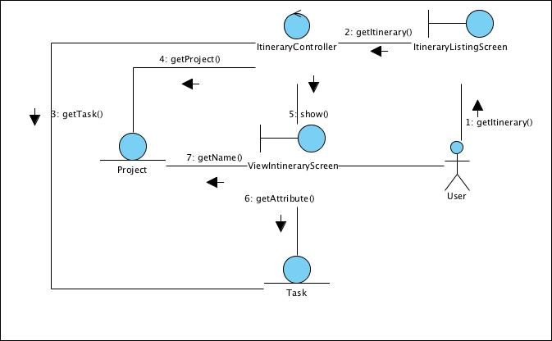
Figure 32 – Collaboration Diagram for View Itinerary

Collaboration Diagram for Create Itinerary
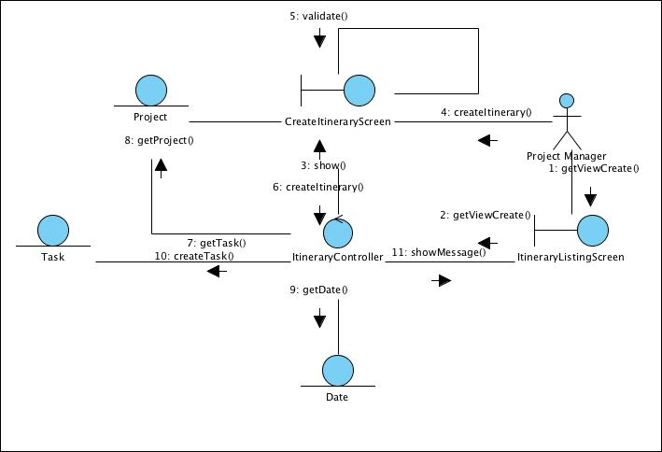
Figure 33 – Collaboration Diagram for Create Itinerary

Collaboration Diagram for Update Itinerary
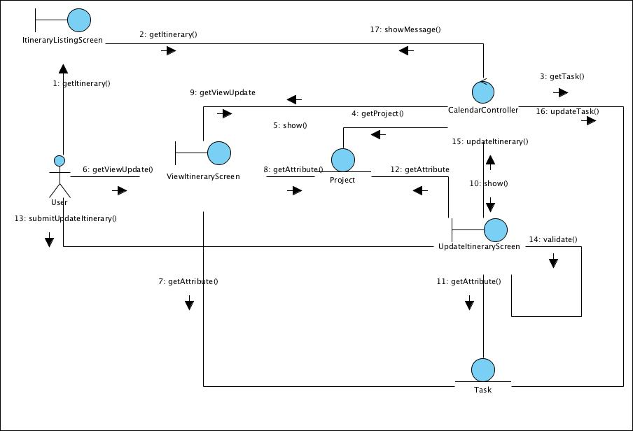
Figure 34 – Collaboration Diagram for Update Itinerary

Collaboration Diagram for Delete Task
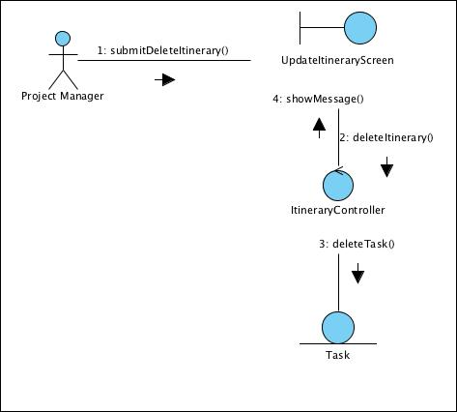
Figure 35 – Collaboration Diagram for Delete Task

Participating Objects

User
This entity object stores the details concerning a user of the volunteer organisation. The primary attribute that it holds is the userID.

Project Manager
This is a Staff object type with a project manager role as an attribute.

Date
This entity object stores the current date.

Task
This entity object stores the details concerning a task of a project’s itinerary. The primary attribute that it holds is the projectID.

Project
This entity object stores the details concerning a task of the volunteer organisation. The primary attribute that it holds is the taskID.

ItineraryListingScreen
This boundary object is used for collection of task listing details. User actor uses this object.

CreateItineraryScreen
This boundary object holds the information of a new task record is to be created for the itinerary. The User actor uses this object.

UpdateItineraryScreen
This boundary object holds the information of a task record is to be updated. The User actor uses this object.

ViewItineraryScreen
This boundary object holds the information of a task record is to be viewed. The User actor uses this object.

HomeScreen
This boundary object is used for redirecting and displaying of home screen details and menu. All the user actors use this object.

MainController
This control object co-ordinates the menu selection and dispatches of requests of the volunteer management system. It delegates the user requests to the specific use case control objects for carrying out the use cases.

ItineraryController
This control object co-ordinates the creation, update and viewing itinerary task record in the volunteer management system. It receives requests from the boundary objects allocated for the specific purposes, along with all the necessary details required for the execution of these requests.

Class Diagram
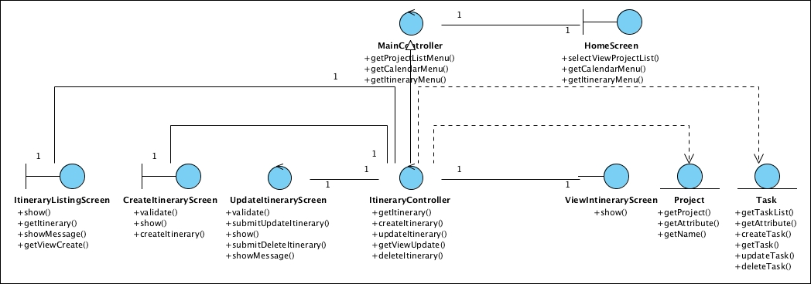
Figure 36 – Class Diagram

Derived Requirements
The User office PC (client system), keyboard and mouse will be used to process the project details and view all the system responses.

Use Case Realisation Report (Analysis) – manage calendar
FOR
Volunteer Management System (VMS)
(VMS)

UCRR (Analysis) – Manage Calendar

Brief Description
The use case enables a User to view a calendar of events based on month.

Flow of Events
The standard flow of events for this use case and any exceptions are described in the following subsections. See section 14.6 for an overview of the participating Actors and Domain Objects.

Standard Flow
Precondition: User has logged in the system.
This use case provides the user interface related functionality that will be provided to the Project Manager for interaction with regards to calendar management, as follows:

List Event
- The use case starts when the User selects the calendar option from the HomeScreen. The HomeScreen.getCalendarMenu() operation is triggered.
- The getCalendarMenu() operation triggers the MainController.getCalendarMenu() which delegates to the CalendarController.getEventList() operation.
- Using the userID and date, the CalendarController.getEventList() operation triggers Event.getEventList() operation to retrieve the calendar event records using the userID and date. The CalendarController.getEventList() operation triggers also triggers the Attendee.getAttendee() operation to retrieve the attend records based on the eventID.
- The CalendarController triggers the CalendarListingScreen.show() operation to display the list of projects by triggering the Event.getAttribute() operation, Staff.getAttribute() operation and the Project.getProject() operation.
- The use case terminates.

View Event
- The use case starts when the User selects a record to view from the CalendarListingScreen. The CalendarListingScreen.getEvent() operation is triggered.
- Using the eventID, the CalendarController.getEvent() operation triggers Event.getEvent() operation to retrieve the calendar event details based on the eventID and the Attendee.getAttendee() operation is triggered to retrieve the attendees who are participating in the event.
- The CalendarController triggers the ViewCalendarScreen.show() operation to display the ViewCalendarScreen by triggering the Event.getAttribute() operation to retrieve the event details, the Attendee.getAttribute() operation to display the attendees’ details and Project.getName() to retrieve the project name.
- The use case terminates.

Create Event
- The use case starts when the User selects the create event option from the CalendarListingScreen. The CalendarListingScreen.getViewCreate() operation is triggered.
- The CalendarController triggers the CreateCalendarScreen.show() operation to display the CreateCalendarScreen.
- The User enters the calendar event details of the new calendar event into the text fields of CreateCalendarScreen.
- When the User selects the Create button in the form, the CreateCalendarScreen.validate() operation performs form validation based on the input fields.
- Upon successful validation, CreateCalendarScreen.createProject() operation triggers the CalendarController.createEvent() operation and provides the Event object by triggering the Event.getEvent(), retrieves the list of Attendee object by triggering the Attendee.getAttendee() operation and Project.getProject() operation to retrieve the project object to get the project ID to create a event. The createEvent() operation assigns a new event ID by using the operation Event.getNextEventID() operation.
- The CalendarController.createEvent() operation sets the date of created date of the event which the date is retrieved via the Date.getDate().
- The CalendarController triggers Event.createEvent() operation to create the new Event object details including name, description, location, startDate, endDate, attendees and remarks. The system displays an informational message for successfully updated message in the CalendarListingScreen by triggering the CalendarListingScreen.showMessage() operation.
- The use case terminates.

Update Event
- The use case starts when the Project Manager selects a record from the CalendarListingScreen. The CalendarListingScreen.getViewUpdate() operation is triggered.
- The CalendarController.getViewUpdate() operation triggers Attendee.getAttendee() operation to retrieve the attendee details and the Event.getEvent() operation is triggered to retrieve the event details.
- The CalendarController triggers the ViewCalendarScreen.show() operation to display the UpdateCalendarScreen by triggering the Attendee.getAttribute() operation to retrieve the attendee detail, the Event.getAttribute() operation and Project.getAttribute() to display the details.
- The User selects the Update button to update the updates the project details of the project into the text fields of UpdateCalendarScreen.
- When the User selects the Update button in the form, the UpdateCalendarScreen.validate() operation performs form validation based on the input fields.
- Upon successful validation, UpdateCalendarScreen.updateEvent() operation triggers the CalendarController.updateEvent() operation and provides the Event object to update the event.
- The CalendarController triggers Event.updateEvent() operation to update the new Event object details including including name, description, location, startDate, endDate, attendees and remarks. The system displays an informational message for successfully updated message in the CalendarListingScreen by triggering the CalendarListingScreen.showMessage() operation
- The use case terminates.

Publish Event
- The use case starts when the Project Manager selects the update project option from the CalendarListingScreen. The update option is performed by the Update use case.
- The Project Manager checks the checkbox Publish to publish the calendar to the team member’s calendar. The flow is the same as the Update use case with an additional indicator publishIndicator to be updated as Yes.
- The use case terminates.

Exceptions
The following exceptions were identified:
- Validation fails. If the CreateCalendarScreen.validate() operation fails, the project creation fails. An error message is displayed in the CreateCalendarScreen by triggering the operation CreateCalendarScreen.showMessage().
- Validation fails. If the UpdateCalendarScreen.validate() operation fails, the project creation fails. An error message is displayed in the UpdateCalendarScreen by triggering the operation UpdateCalendarScreen.showMessage().

Interaction Diagrams

Collaboration Diagram for List Event
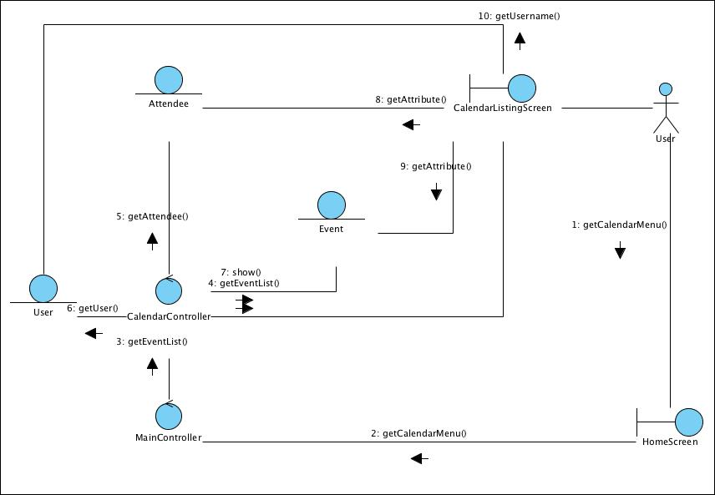
Figure 37 – Collaboration Diagram for List Event

Collaboration Diagram for View Event
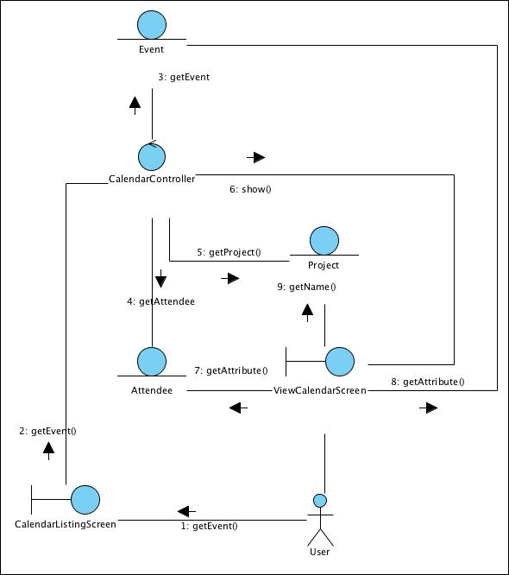
Figure 38 – Collaboration Diagram for View Event

Collaboration Diagram for Create Event
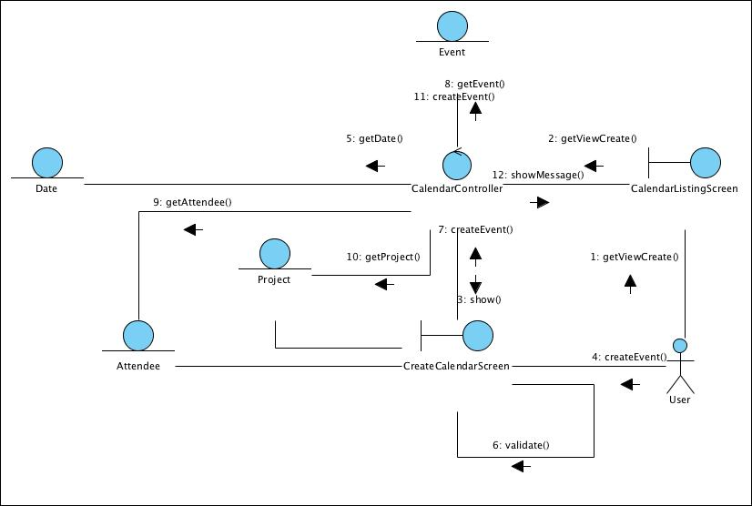
Figure 39 – Collaboration Diagram for Create Event

Collaboration Diagram for Update Event
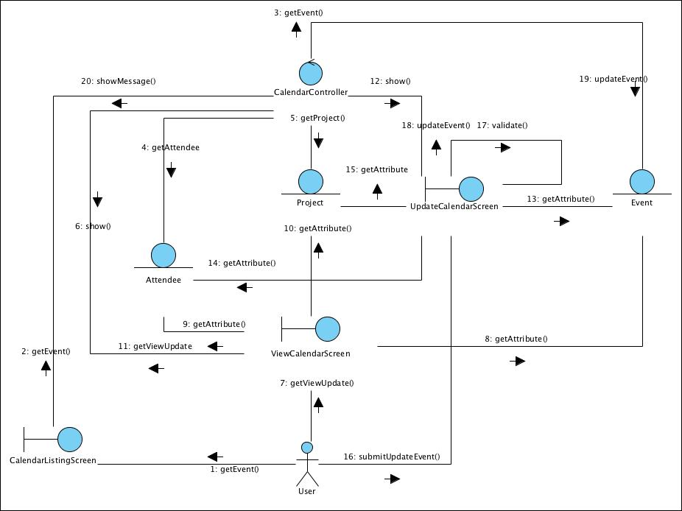
Figure 40 – Collaboration Diagram for Update Event

Participating Objects

User
This entity object stores the details concerning a user of the volunteer organisation. The primary attribute that it holds is the userID.

Project Manager
This is a Staff object type with a project manager role as an attribute.

Date
This entity object stores the current date.

Event
This entity object stores the details concerning a calendar event of a project’s calendar. The primary attribute that it holds is the projectID.

Attendee
This entity object stores the details concerning an attendee who will be participating in an event. The primary attribute that it holds is the userID.

Project
This entity object stores the details concerning a project of the volunteer organisation. The primary attribute that it holds is the projectID.

CalendarListingScreen
This boundary object is used for collection of event listing details. User actor uses this object.

CreateCalendarScreen
This boundary object holds the information of a new event record is to be created. The User actor uses this object.

UpdateCalendarScreen
This boundary object holds the information of an event record is to be updated. The User actor uses this object.

ViewCalendarScreen
This boundary object holds the information of an event record is to be viewed. The User actor uses this object.

HomeScreen
This boundary object is used for redirecting and displaying of home screen details and menu. All the user actors use this object.

MainController
This control object co-ordinates the menu selection and dispatches of requests of the volunteer management system. It delegates the user requests to the specific use case control objects for carrying out the use cases.

CalendarController
This control object co-ordinates the creation, update and viewing calendar event record in the volunteer management system. It receives requests from the boundary objects allocated for the specific purposes, along with all the necessary details required for the execution of these requests.

Class Diagram
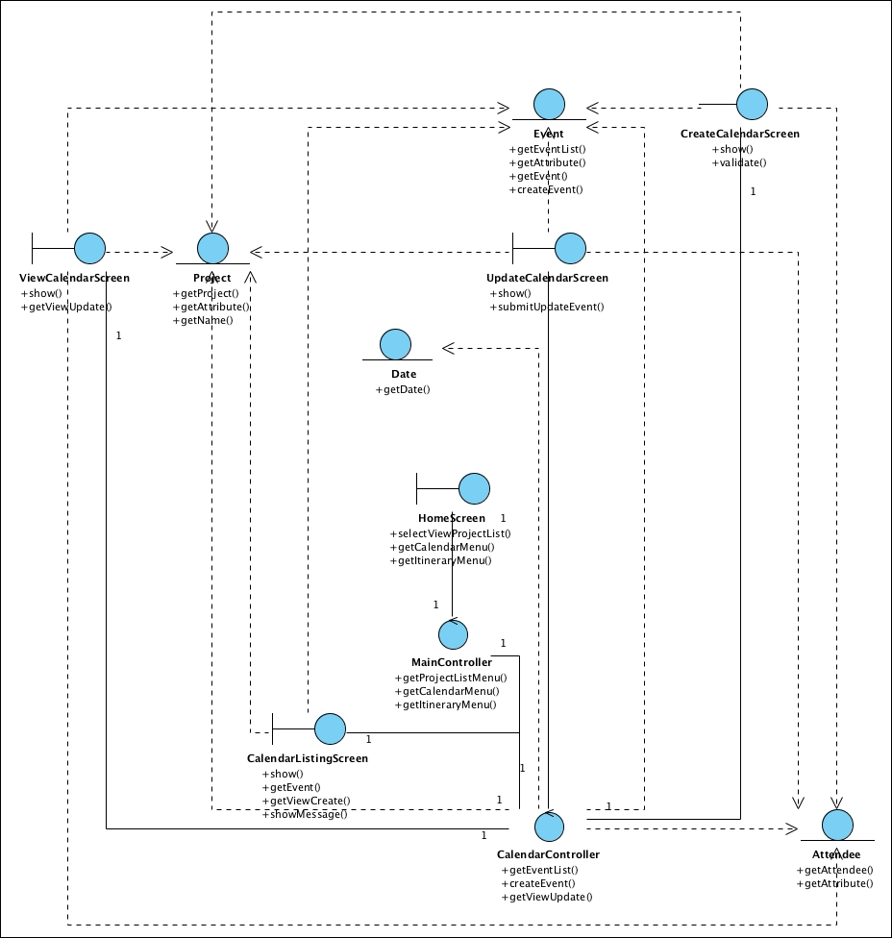
Figure 41 – Class Diagram

Derived Requirements
The User office PC (client system), keyboard and mouse will be used to process the project details and view all the system responses.

Use Case Realisation Report (Analysis) – review project Feedback
FOR
Volunteer Management System (VMS)
(VMS)

UCRR (Analysis) – Review Project Feedback

Brief Description
The use case enables a Project Manager to review the list of user posted experience regarding the projects under him and decide whether to publish the user-content.

Flow of Events
The standard flow of events for this use case and any exceptions are described in the following subsections. See section 15.6 for an overview of the participating Actors and Domain Objects.

Standard Flows
Precondition: User has logged in the system and the user role is project coordinator
- The use case starts when the Project Manager selects the menu option from the HomeScreen. The HomeScreen. getProjectExperienceScreen() operation is triggered.
- The getProjectExperienceScreen() operation triggers the MainController.getCalendarMenu() which delegates to the CalendarController. reviewProjectExperience() operation.
- Then the MainController delegate to the FeedbackController.getProjectExperience() operation.
- The FeedbackController will then use the StaffController.getStaff() to get a staff profile,which in turn trigger Staff.getStaff().
- With the staff profile, the FeedbackController use the ProjectController.getProjectOfStaff() , which in turn will call the Project.getProject() to return a list of project under this Project Manager.
- With the list of project, the FeedbackController will call the Feedback.getFeedback() to return a list of all user posted project experience regarding the list of projects.
- FeedbackController will then show the list of feedback via the FeedbackDetailScreen.show() method.
- The Project Manager now can review and decide whether to publish the content, which will trigger the updateFeedback() operation of the FeedbackDetailScreen.
- The updateFeedback() operation is in turn trigger the Feedback.update() to store the data. After that the FeedbackController will return a message via FeedbackDetailScreen.sendMessage().
- The use case terminate when the actor click Close button on the FeedbackDetailScreen, which trigger FeedbackDetailScreen.close() method.

Exceptions
The following exceptions were identified:
- Update fails. If the UserFeedback.update() operation fails, the feedback is not updated. An error message will be displayed in the FeedbackDetailScreen by the operation FeedbackDetailScreen.sendMessage().

Interaction Diagrams

Collaboration Diagram for Review Feedback
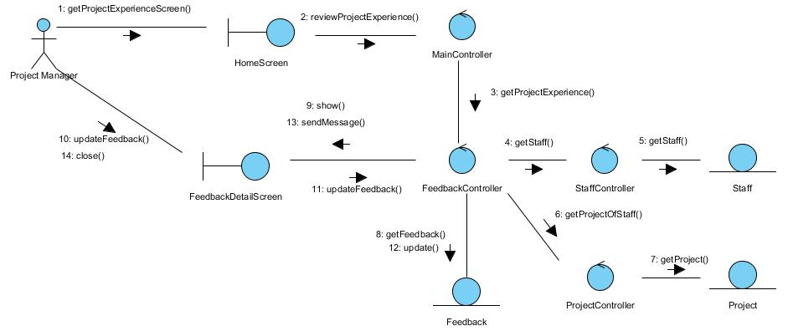
Figure 42 – Collaboration Diagram for Review Feedback

Participating Objects

Staff
This entity object stores the details concerning a staff of the volunteer organisation. The primary attribute that it holds is the userID.

Project Manager
This is a Staff object type with a project manager role as an attribute.

Project
This entity object stores the details concerning a project of the volunteer organisation. The primary attribute that it holds is the projectID.

UserFeedback
This entity object stores the details concerning a user posted content inside the volunteer organisation.

FeedbackDetailScreen
This boundary object is used for displaying the details of user posted experience. Project manager interact with this object.

HomeScreen
This boundary object is used for redirecting and displaying of home screen details and menu. All the user actors use this object.

MainController
This control object co-ordinates the menu selection and dispatches of requests of the volunteer management system. It delegates the user requests to the specific use case control objects for carrying out the use cases.

FeedbackController
This control object co-ordinates the creation, update, viewing and searching of feedback in the volunteer management system. It receives requests from the boundary objects allocated for the specific purposes, along with all the necessary details required for the execution of these requests.

Class Diagram
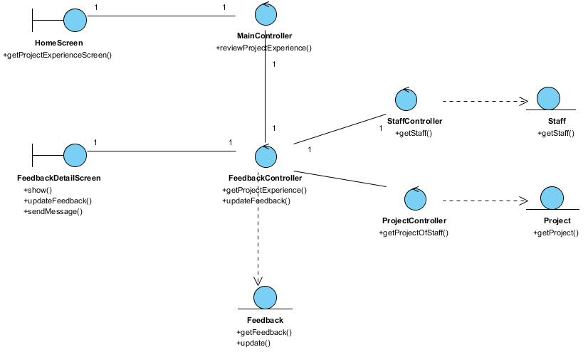
Figure 43 – Class Diagram

Derived Requirements
The User office PC (client system), keyboard and mouse will be used to process the project details and view all the system responses.

Use Case Realisation Report (Analysis) – REview project interest
FOR
Volunteer Management System (VMS)
(VMS)

UCRR (Analysis) – Review Project Interest

Brief Description
The use case enables registered user with project manager review the project interest and reply the project interest by accepting or rejecting the project interest raised by the volunteer. If a volunteer’s project interest is accepted by the project manage, that volunteer will become a project member.

Flow of Events
The standard flow of events for this use case and any exceptions are described in the following subsections. See section 16.6 for an overview of the participating Actors and Domain Objects.

Standard Flow
Precondition: Project Manager has logged in the system.
This use case provides the user interface related functionality that will be provided to the User, as follows:
- The use case starts when the project manager selects the Manage Project Interest option from the HomeScreen user interface. The HomeScreen.manageProjectInterest() method is triggered.
- The MenuScreen.manageProjectInterest() triggers the MainController. manageProjectInterest() operation which delegates to ViewProjectInterestScreen. show().
- The show() launches the user interface ViewProjectInterestScreen.
- The project manager uses the ViewProjectInterestScreen user interface to select or key in the project criteria like the project name. When the project manager clicks the Search button in the screen, ViewProjectInterestScreen.enterSearchCriteria() is called.
- The enterSearchCriteria () will triggers the ProjectInterestController.processSearch() to retrieve the list of the project interest that match the criteria.
- The ProjectInterestController.processSearch() will triggers the ProjectFeedback.findProjectInterest() operation to retrieve the list of the project interest that match the criteria.
- After that, ProjectInterestController triggers the ViewProjectInterestScreen.displayResult() operation to display the list of the matching project interest.
- The ViewProjectInterestScreen.displayResult() operation will also triggers the ProjectInterest.getProjectInterest() operation to retrieves the project feedback records.
- The project manager can update the status of each project interest raised by volunteers and click Update button in the ViewProjectInterestScreen screen. ViewProjectInterestScreen.acceptRejectProjectInterest() operation is called.
- The acceptRejectProjectInterest() will triggers the ProjectInterestController.updateProjectInterestStatus() to update the status of the project interests.
- After that, ProjectInterestController triggers the ProjectInterest.updateProjectInterestStatus() operation to update the status of the project interest request.
- ProjectInterestController will triggers the ProjectInterest.getProjectInterestStatus() and Volunteer.getVolunteer() operations to populate the email context.
- ProjectInterestController triggers the MailServer.sendEmail() operation to notify the result of the project interest to the requested volunteers.
- The use case terminates when the project manager click the Close button of the ViewProjectInterestScreen.
- The use case terminates.

Exceptions
The following exceptions have been identified:
- There is no matching project interest: if there is no matching Project Interest for the selected project, the ProjectInterestController will return empty list of Project Interest passing in the displayResult() and the ViewProjectInterestScreen will show an empty list with the “No project interest found” message.

Interaction Diagrams

Collaboration Diagram for Review Project Interest

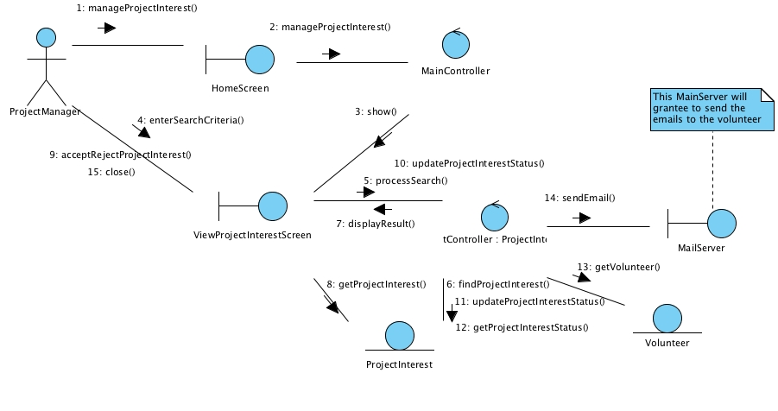
Figure 44 - Collaboration Diagram for Review Project Interest

Participating Objects

HomeScreen
This boundary object is used for redirecting and displaying of home screen details and menu. All the user actors use this object.

ViewProjectInterestScreen
The boundary object is used to display the list of volunteer who are interested to join the project and also display the status of whether they are allowed to join the project or not.

MailServer
This boundary object is used to interact with Microsoft Exchange Server and provide email services.

MainController
This control object co-ordinates the menu selection and dispatches of requests of the volunteer management system. It delegates the user requests to the specific use case control objects for carrying out the use cases.

ProjectInterestController
The control object co-ordinates the retrieving of project interest related information based on search criteria from user.

Volunteer
This entity object stores the details concerning a volunteer of the volunteer organisation. The primary attribute that it holds is the userID.

ProjectInterest
This entity object stores the details information of volunteer who are interested to participate in the project.

Class Diagram

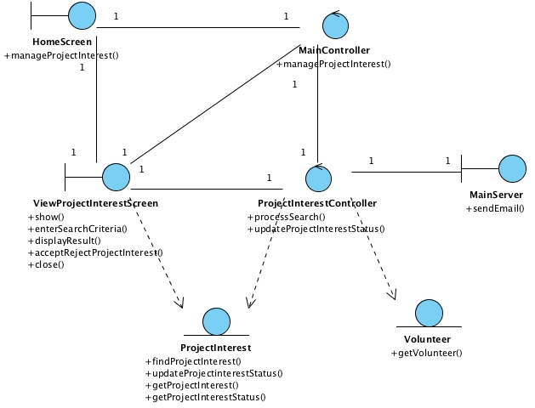

Figure 45 – Class Diagram

Derived Requirements
The User office PC (client system), keyboard and mouse will be used to process the project details and view all the system responses.

Use Case Realisation Report (Analysis) – Print certificate
FOR
Volunteer Management System (VMS)
(VMS)

UCRR (Analysis) – Print Certificate

Brief Description
The use case enables the System Administrator to print certificate of a volunteer for the projects that he/she has participated in.

Flow of Events
The standard flow of events for this use case and any exceptions are described in the following subsections. See section 17.6 for an overview of the participating Actors and Domain Objects.

Standard Flow
Precondition: GenerateCertificate use case has been executed.
This use case provides the user interface related functionality that will be provided to the System Administrator as follows:
- When the system administrator clicks ‘Print Certificate’ button, the method MainController .printCertificateScreen() is triggered.
- The MainController.printCertificateScreen() will use the method CertificateController.getCertificate() to get the certificate for the specified volunteer.
- CertificateController.getCertificate() will use the Certificate.getCertificateData() method to get Certificate data.
- The PrintCertificate screen will show, and get certificate data for printing.
- The use case terminates.

Exceptions
No exceptions were identified.

Interaction Diagrams

Collaboration Diagram for Print Certificate
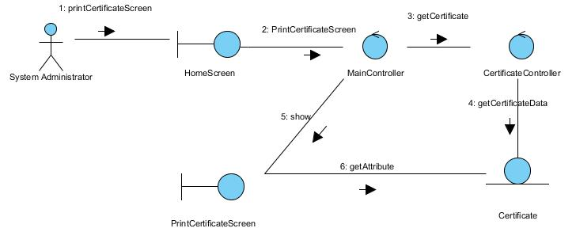
Figure 46 – Collaboration Diagram for Print Certificate

Participating Objects

Certificate
This entity object stores the details concerning a certificate of the volunteer. The primary attribute that it holds is the certificateID.

MainController
This controller object co-ordinates the menu selection and dispatches of requests of the volunteer management system. It delegates the user requests to the specific use case controller objects for carrying out the use cases.

CertificateController
This controler object co-ordinates the printing of the certificate in the volunteer management system. It receives requests from the boundary objects allocated for the specific purposes, along with all the necessary details required for the execution of these requests.

PrintCertificateScreen
This boundary object is used for retrieve the request of printing of certificate. The User actor uses this object.

HomeScreen
This boundary object is used for redirecting and displaying of home screen details and menu. All the user actors use this object.

Class Diagram

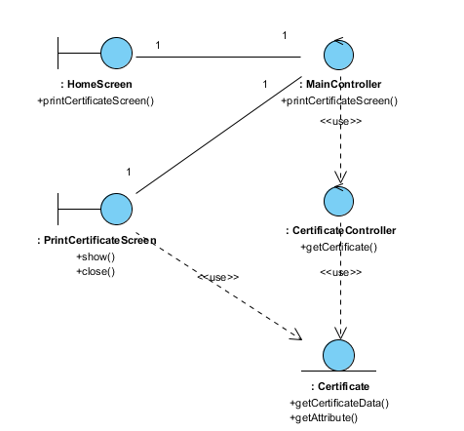

Figure 47 – Class Diagram

Derived Requirements
The User office PC (client system), keyboard and mouse will be used to process the project details and view all the system responses.

Use Case Realisation Report (Analysis) – generate certificate by batch
FOR
Volunteer Management System (VMS)
(VMS)

UCRR (Analysis) – Generate Certificate By Batch

Brief Description
The use case enables registered user with system administrator role to generate batch of certificates requested by project manager for specific project.

Flow of Events
The standard flow of events for this use case and any exceptions are described in the following subsections. See section 18.6 for an overview of the participating Actors and Domain Objects.

Standard Flow
Precondition: System Administrator has logged in the system.
This use case provides the user interface related functionality that will be provided to the User, as follows:
- The use case starts when the system administrator selects the Generate Certificate option from the HomeScreen user interface. The HomeScreen.getGenerateCertificateScreen() method is triggered.
- The HomeScreen.getGenerateCertificateScreen() triggers the MainController.show() operation which delegates to GenerateCertificateScreen.show().
- The show() launches the user interface GenerateCertificateScreen.
- The system administrator uses the GenerateCertificateScreen user interface to select or key in the certificate criteria like the volunteer name. When the system administrator clicks the Generate Certificate button in the form, GenerateCertificate Screen.enterCertificateCriteria() is called.
- The enterCertificateCriteria() will triggers the CertificateController.generateCertificate() to get the details information of volunteer and project that match the criteria.
- The CertificateController.generateCertificate() will triggers the Volunteer.getVolunteerDetails() operation to retrieve the details information of Volunteer and Project.getProjectDetails() operation to retrieve the details information of Project that match the criteria.
- After that, CertificateController triggers the CertificateController.returnCertificate() operation to get the certificate of requested volunteers for specific project.
- The use case terminates.

Exceptions
The following exceptions have been identified:
- There is no matching Certificate: if there is no matching Certificate for the selected project, the CertificateController will return empty data of Certificate and the GenerateCertificateScreen will show “No certificate found” message.

Interaction Diagrams

Collaboration Diagram for Generate Certificate By Batch
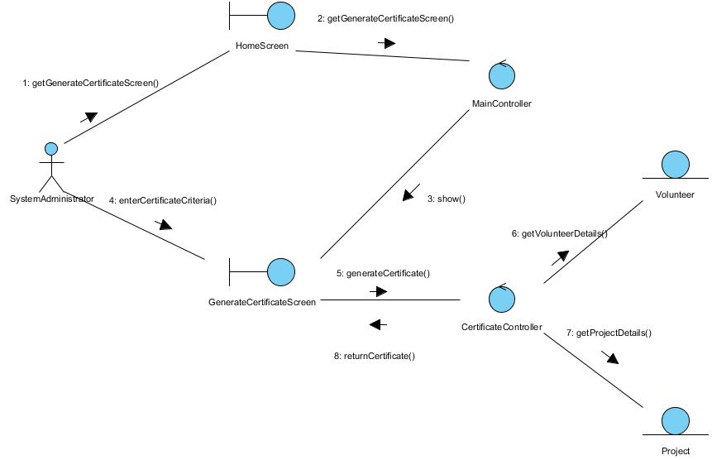
Figure 48 – Collaboration Diagram for Generate Certificate By Batch

Participating Objects

HomeScreen
This boundary object is used to display the main menu of the system. The System Administrator actor uses this object to launch other user interfaces.

MainController
This control object coordinates the menu selection of the VMS system. It delegates the user requests to the specific use case control object for carrying out the use cases.

GenerateCertificateScreen
This boundary object is used to enter certificate criteria of requested volunteer by system administrator.

CertificateController
This control object coordinates the retrieving data of volunteer and project for certificate and generating certificate.

Project
This entity object stores all the project related details. This object represents information to be stored on a persistent basis.

Volunteer
This entity object stores all the volunteer details. This object represents information to be stored on a persistent basis.

Class Diagram

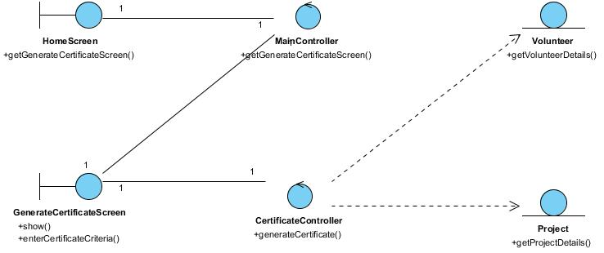
Figure 49 – Class Diagram

Derived Requirements
The User office PC (client system), keyboard and mouse will be used to process the project details and view all the system responses.

Use Case Realisation Report (Analysis) – generate separate certificate
FOR
Volunteer Management System (VMS)
(VMS)

UCRR (Analysis) – Generate Separate Certificate

Brief Description
The use case enables registered user with system administrator role to generate separate certificate requested by volunteer.

Flow of Events
The standard flow of events for this use case and any exceptions are described in the following subsections. See section 19.6 for an overview of the participating Actors and Domain Objects.

Standard Flow
Precondition: System Administrator has logged in the system.
This use case provides the user interface related functionality that will be provided to the User, as follows:
- The use case starts when the system administrator selects the Generate Certificate option from the HomeScreen user interface. The HomeScreen.getGenerateCertificateScreen() method is triggered.
- The HomeScreen.getGenerateCertificateScreen() triggers the MainController.show() operation which delegates to GenerateCertificateScreen.show().
- The show() launches the user interface GenerateCertificateScreen.
- The system administrator uses the GenerateCertificateScreen user interface to select or key in the certificate criteria like the volunteer name. When the system administrator clicks the Generate Certificate button in the form, GenerateCertificateScreen.enterCertificateCriteria() is called.
- The enterCertificateCriteria() will triggers the CertificateController.generateCertificate() to get the details information of volunteer and project that match the criteria.
- The CertificateController.generateCertificate() will triggers the Volunteer.getVolunteerDetails() operation to retrieve the details information of Volunteer and Project.getProjectDetails() operation to retrieve the details information of Project that match the criteria.
- After that, CertificateController triggers the CertificateController.returnCertificate() operation to get the certificate of requested volunteer.
- .The use case terminates after the system administrator retrieves the certificate.

Exceptions
The following exceptions have been identified
- There is no matching Certificate: if there is no matching Certificate for the selected project, the CertificateController will return empty data of Certificate and the GenerateCertificateScreen will show “No certificate found” message.

Interaction Diagrams

Collaboration Diagram for Generate Separate Certificate
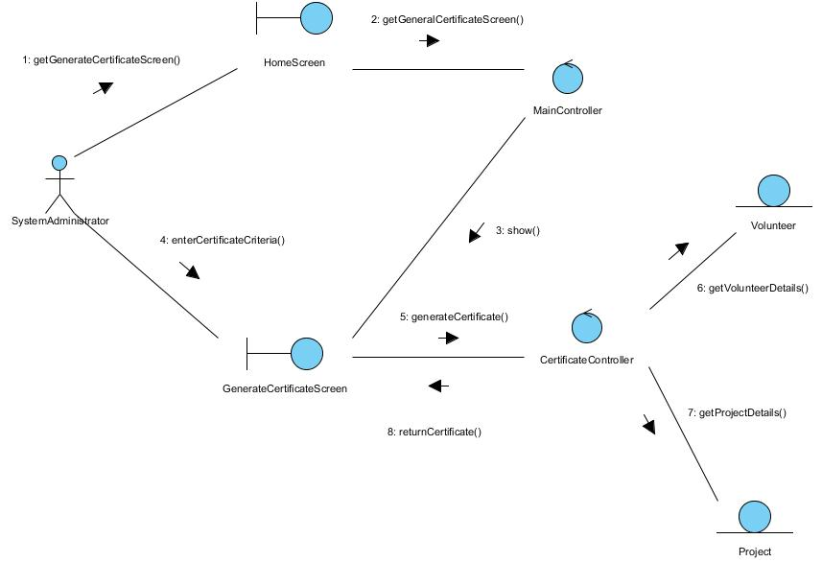
Figure 50 – Collaboration Diagram for Generate Separate Certificate

Participation Objects

HomeScreen
This boundary object is used to display the main menu of the system. The System Administrator actor uses this object to launch other user interfaces.

MainController
This control object coordinates the menu selection of the VMS system. It delegates the user requests to the specific use case control object for carrying out the use cases.

GenerateCertificateScreen
This boundary object is used to enter certificate criteria of requested volunteer by system administrator.

CertificateController
This control object coordinates the retrieving data of volunteer and project for certificate and generating certificate.

Project
This entity object stores all the project related details. This object represents information to be stored on a persistent basis.

Volunteer
This entity object stores all the volunteer details. This object represents information to be stored on a persistent basis.

Class Diagram

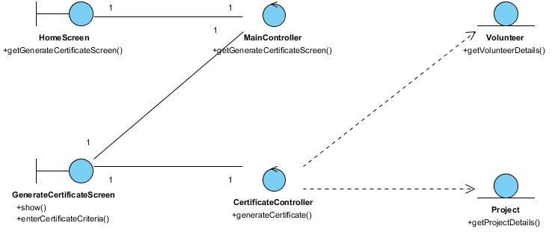
Figure 51 – Class Diagram

Derived Requirements
The User office PC (client system), keyboard and mouse will be used to process the project details and view all the system responses.

Use Case Realisation Report (Analysis) – generate Report
FOR
Volunteer Management System (VMS)
(VMS)

UCRR (Analysis) – Generate Report

Brief Description
This use case allows the batch scheduler to generate reports based on predefined schedule.

Flow of Events
The standard flow of events for this use case and any exceptions are described in the following subsections. See section 20.6 for an overview of the participating Actors and Domain Objects.

Standard Flow
This use case provides the functionality that will be provided to the batch scheduler as follows:
- When the user clicks ‘Generate Report’ button, the method MainController .getReportScreen() is triggered.
- The MainController.getReportScreen () will use the method ReportController.getReport() to get the report.
- ReportController.getReport () will use the ReportData.getReportData() method to get Report data.
- The PrintReportScreen will show, and get report data for printing.
- The use case terminates.

Exceptions
No exceptions have been identified.

Interaction Diagrams

Collaboration Diagram for Generate Report
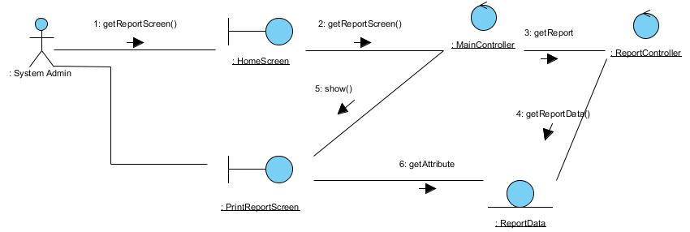
Figure 52 – Collaboration Diagram for Generate Report

Participating Objects

ReportData
This entity object stores the details data concerning a report.

MainController
This controller object co-ordinates the menu selection and dispatches of requests of the volunteer management system. It delegates the user requests to the specific use case controller objects for carrying out the use cases.

ReportController
This controller object co-ordinates the generating of a report in the volunteer management system. It receives requests from the boundary objects allocated for the specific purposes, along with all the necessary details required for the execution of these requests.

PrintReportScreen
This boundary object is used for retrieve the request of printing of report. The User actor uses this object.

HomeScreen
This boundary object is used for redirecting and displaying of home screen details and menu. All the user actors use this object.

Class Diagram

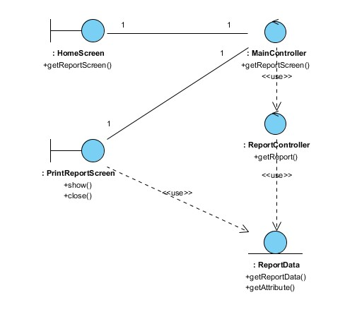

Figure 53 – Class Diagram

Derived Requirements
The User office PC (client system), keyboard and mouse will be used to process the project details and view all the system responses.

Use Case Realisation Report (Analysis) – search project feedback
FOR
Volunteer Management System (VMS)
(VMS)

UCRR (Analysis) – Search Project Feedback

Brief Description
The use case enables registered user with project manager role to search/view the project feedback.

Flow of Events
The standard flow of events for this use case and any exceptions are described in the following subsections. See section 21.6 for an overview of the participating Actors and Domain Objects.

Standard Flow

Precondition: Project Manager has logged in the system.
This use case provides the user interface related functionality that will be provided to the User, as follows:
- The use case starts when the project manager selects the Search Project Feedback option from the HomeScreen user interface. The HomeScreen.selectSearchProjectFeedback() method is triggered.
- The HomeScreen.selectSearchProjectFeedback() triggers the MainController.searchProjectFeedback() operation which delegates to ProjectFeedbackSearchScreen.diplayScreen().
- The displayScreen() launches the user interface ProjectFeedbackSearchScreen.
- The project manager uses the ProjectFeedbackSearchScreen user interface to select or key in the project feedback criteria like the project name. When the project manager clicks the Search button in the form, ProjectFeedbackSearchScreen.enterSearchCriteria() is called.
- The enterSearchCriteria() will triggers the ProjectFeedbackController.processSearch() to retrieve the list of the project feedback that match the criteria.
- The ProjectFeedbackController.processSearch() will triggers the ProjectFeedback.findProjectFeedbackByProject() operation to retrieve the list of the project feedback that match the criteria.
- After that, ProjectFeedbackController triggers the ProjectFeedbackSearchScreen.displayResult() operation to display the list of the matching project feedback.
- The ProjectFeedbackSearchScreen.displayResult() operation will also triggers the ProjectFeedback.getProjectFeedback() operation to retrieves the project feedback records.
- The use case terminates when the project manager click the Close button of the ProjectFeedbackSearchScreen.

Exceptions
The following exceptions have been identified:
- There is no matching project feedback: if there is no matching Project Feedback for the selected project, the ProjectFeedbackController will return empty list of Project Feedback passing in the displayResult() and the ProjectFeedbackSearchScreen will show an empty list with the “No project feedback found” message.

Interaction Diagrams

Collaboration Diagram for Search Project Feedback

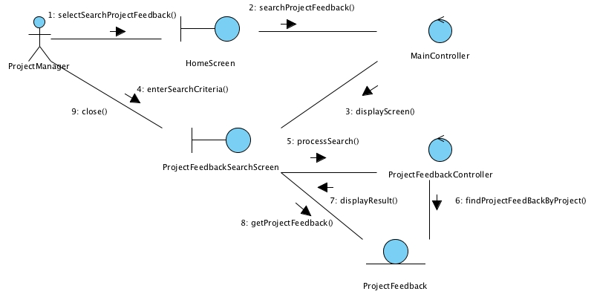
Figure 54 – Collaboration Diagram for Search Project Feedback

Participating Objects

HomeScreen
This boundary object is used for redirecting and displaying of home screen details and menu. All the user actors use this object.

MainController
This control object co-ordinates the menu selection and dispatches of requests of the volunteer management system. It delegates the user requests to the specific use case control objects for carrying out the use cases.

ProjectFeedbackController
This control object co-ordinates the ProjectFeedback information update, creation and retrieval.

ProjectFeedback
This entity object stores the details concerning a project feedback.

ProjectFeedbackSearchScreen
This boundary object is used to display project feedback info and allow user to search the project feedback.

Class Diagram

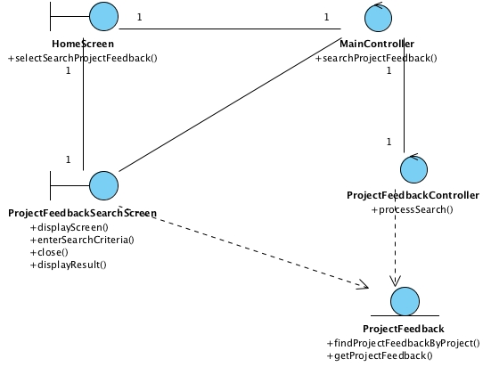

Figure 55 – Class Diagram

Derived Requirements
The User office PC (client system), keyboard and mouse will be used to process the project details and view all the system responses.

Use Case Realisation Report (Analysis) – search project Member
FOR
Volunteer Management System (VMS)
(VMS)

UCRR (Analysis) – Search Project Member

Brief Description
The use case enables any user of the system (can be a volunteer or internal staff) to view the member list of a project. Information display is based on the roles of the user.

Flow of Events
The standard flow of events for this use case and any exceptions are described in the following subsections. See section 23.6 for an overview of the participating Actors and Domain Objects.

Standard Flows
Precondition: User has logged in the system
The workflow is as below:
- The use case starts when the User selects the menu option from the HomeScreen. The HomeScreen.searchProjectMember() operation is triggered.
- The HomeScreen searchProjectMember() operation delegates to the MainController searchProjectMember() operations, which in turn trigger the displaySearchMemberScreen() operation of the MembershipController.
- The MembershipController will then using the UserController.getUserDetail() method to get the current logged in user via the User.getUser().
- Then the MembershipController will trigger ProjectController.getProjectList() to get the list of all projects available for viewing members
- Based on the user profile and the project list, the MembershipController will trigger Membership.getMembership() to return the list of member for each project.
- Then the MembershipController will display the list via MembershipListingScreen show() method.
- The user then key in the search criteria and click Search, which trigger MembershipListingScreen.searchMember() method.
- Using the parameter in searchMember(), the MembershipListingScreen will call the searchMemberByCriteria() method of MembershipController, which then will filter the list and display on the screen via showFilteredResult() method
- User now can see the list of the project member on the MembershipListingScreen, the use case terminates when user click Close button which trigger close() method of the screen.

Exceptions
The following exceptions were identified:
- No result return. If the MembershipController.showFilteredResult() operation does not return any record , the MembershipListingScreen still show with an empty listing for that project.

Interaction Diagrams

Collaboration Diagram for Search Project Member
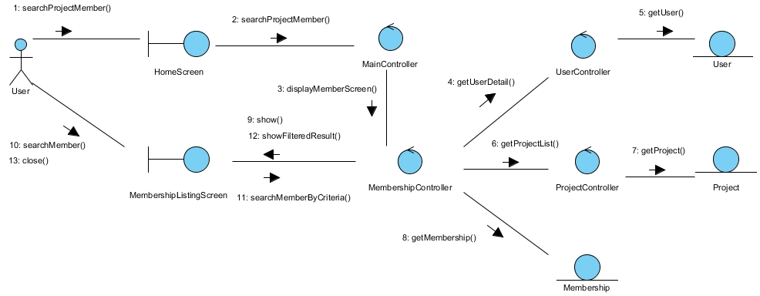
Figure 56 – Collaboration Diagram for Search Project Member

Participating Objects

User (Entity)
This entity object represents a registered user of the system, and stores the detailed profile of that user. The primary attribute that it holds is the userID.

User (Actor)
This is a user actor type, which represents anyone who interacts with the system.

Project
This entity object stores the details concerning a project of the volunteer organisation. The primary attribute that it holds is the projectID.

Membership
This entity object stores the details concerning the membership of a volunteer in a project inside the volunteer organisation. The primary attribute that it holds is the membershipID.

MembershipListingScreen
This boundary object is used for displaying a collection of project members. User actor uses this object.

HomeScreen
This boundary object is used for redirecting and displaying of home screen details and menu. All the user actors use this object.

MainController
This control object co-ordinates the menu selection and dispatches of requests of the volunteer management system. It delegates the user requests to the specific use case control objects for carrying out the use cases.

MembershipController
This control object co-ordinates the creation, update, viewing and searching project record in the volunteer management system. It receives requests from the boundary objects allocated for the specific purposes, along with all the necessary details required for the execution of these requests.

UserController
This controller object co-ordinate the operations on a user profile (searching, viewing, creating of user profile). In this use case it will be in charge of getting the user profile details.

ProjectController
This controller object co-ordinate the operations on a project entity (searching, viewing, creating, updating). In this use case it will be in charge of getting the project entity details.

Class Diagram
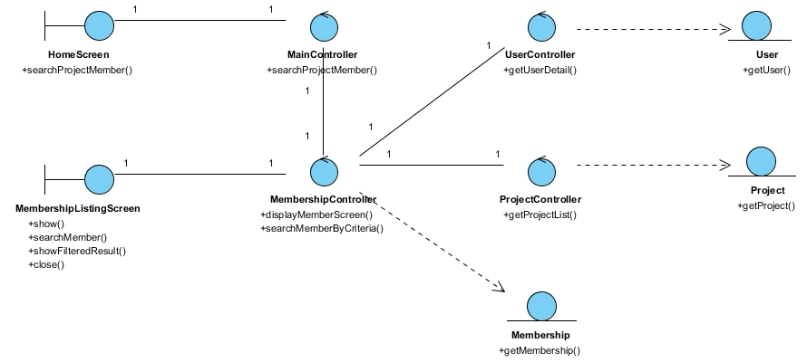
Figure 57 –Class Diagram

Derived Requirements
The User office PC (client system), keyboard and mouse will be used to process the project details and view all the system responses.

Use Case Realisation Report (Analysis) – search project proposal
FOR
Volunteer Management System (VMS)
(VMS)

UCRR (Analysis) – Search Project Proposal

Brief Description
The use case enables a Project Coordinator to view the list of project proposal.

Flow of Events
The standard flow of events for this use case and any exceptions are described in the following subsections. See section 3.1 for an overview of the participating Actors and Domain Objects.

Standard Flow
Precondition: User has logged in the system and the user role is project coordinator
The workflow is as below:
- The use case starts when the Coordinator selects the menu option from the HomeScreen. The HomeScreen.getProjectProposalScreen() operation is triggered.
- The getProjectProposalScreen() operation triggers the MainController. getProjectProposalScreen() which delegates to the loadProposalList() operation of the ProposalController
- Then the ProposalController trigger the getStaffDetails() operation of the StaffController, which in turn call the getStaff() operation from the corresponding entity.
- Using the staff profile, the ProposalController triggers the getProjectProposal() from the corresponding ProjectProposal entity.
- Now the coordinator see the list of project proposal belongs to him, he can perform a search on the ProjectProposalListingScreen.search() method
- This method will trigger the ProposalController.searchByCriteria(), then the ProposalController return the result via ProjectProposalListingScreen showFilteredResult() operation
- The use case terminates when the user select Close button which trigger close() method on ProjectProposalListingScreen.

Exceptions
No exception has been identified.

Interaction Diagrams

Collaboration Diagram for Search Project Proposal
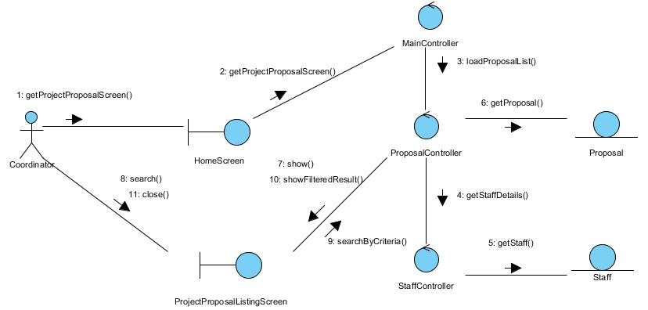
Figure 58 – Collaboration Diagram for Search Project Proposal

Participating Objects

Staff
This entity object stores the details concerning a staff of the volunteer organisation. The primary attribute that it holds is the userID.

Coordinator
This is an actor type, which represents a user with coordinator role in the system.

ProjectProposal
This entity object stores the details concerning a proposal of a project in the volunteer organisation. The primary attribute that it holds is the projecProposalID.

ProjectProposalListingScreen
This boundary object is used for collection of project proposal details. Coordinator actor interacts with this object.

HomeScreen
This boundary object is used for redirecting and displaying of home screen details and menu. All the user actors use this object.

MainController
This control object co-ordinates the menu selection and dispatches of requests of the volunteer management system. It delegates the user requests to the specific use case control objects for carrying out the use cases.

ProposalController
This control object co-ordinates the creation, update, viewing and searching of project proposal record in the volunteer management system. It receives requests from the boundary objects allocated for the specific purposes, along with all the necessary details required for the execution of these requests.

StaffController
This control object co-ordinates the creation, update, viewing and searching of staff record in the volunteer management system. In this use case it is used to get a profile of a logged-in user.

Class Diagram
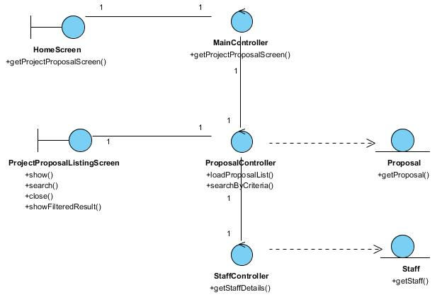
Figure 59 – Class Diagram

Derived Requirements
The User office PC (client system), keyboard and mouse will be used to process the project details and view all the system responses.

ANNEX D Amendment History

This is a record of all amendments made to the Document.
Version | Chapter / Section | Page No | Notes of Amendments or Changes

